

**Brotecs Technologies, LLC.**

20, Shahjalal Avenue, Sector-4, Uttara,

Dhaka-1230, Bangladesh.

E-mail: [info@brotecs.com](mailto:info@brotecs.com)

Website: [www.brotecs.com](http://www.brotecs.com)

**Minu Monitor – Android Edition**

***User Guide***

This guide provides procedures for Usage guidelines of **Minu** **Monitor**for **Android Edition*.*** The Steps are illustrated in an easy-to-understand manner.

**Legal Notice**

|  |
| --- |
| **WARNING --** This document contains technical data subject to the International Traffic in Arms Regulation (ITAR) or the Export Administration Regulation (EAR) of 1979. This data may not be exported, released, or disclosed to foreign nationals without the requisite Export License and/or a Technical Assistance Agreement. A violation of these export laws is subject to severe criminal penalties. Include this notice with any reproduction portion of this document. |

**DOC**.**BTL.MINU_MONITOR.001.002**

**Page | T- 1**

**Initial January 24, 2023**

**Revised January 30, 2023**

|  |  |
| --- | --- |
| **D****ocument Information Table** | |
| Prepared by | Shahnama Monalisa |
| Document No | DOC.BTL.MINU_MONITOR.001.002 |
| Revision No | 1 |
| Page Count | 48 |
| Creation Date | 24.01.2023 |

REVISION TABLE

|  |  |  |  |
| --- | --- | --- | --- |
| **Rev.** | **Description** | **Changed By** | **Date** |
| v1 | Full document ready | Shahnama Monalisa | 1/30/2024 |

TABLE OF CONTENTS

REVISIONTABLE 1

TABLE OF CONTENTS 2

TABLE OF FIGURES 4

Disclaimer 1

Introduction 2

Overview 1

1 Application Launching 2

2 New Account Sign Up 3

3 Sign In to App 5

4 Connect And Disconnect 6

4.1 How to Connect Vital Signs Monitor Device to App 6

4.2 How to Disconnect Vital Signs Monitor Device From App 8

5 Measure 9

5.1 How to measure ECG 9

5.2 How to measure Blood Pressure 10

5.3 How to measure Blood Oxygen 11

5.4 How to measure Blood Glucose 12

5.5 How to measure Body Temperature 13

6 Record 14

6.1 ECG Record 15

6.2 Blood Pressure Record 15

6.3 Blood Oxygen Record 16

6.4 Blood Glucose Record 16

6.5 Body Temperature Record 17

7 Appointment 18

7.1 Add a new Appointment 18

7.2 Appointment list 22

8 More 23

8.1 Profile 24

8.2 About 25

8.3 Settings 26

8.3.1 How to change Temperature Unit 27

8.3.2 How to change Blood Glucose Unit 27

8.3.3 How to change Paper Speed value 28

8.3.4 How to change Gain value 28

8.3.5 How to unbind Vital Signs Monitor Device 29

8.3.1 How to change timeline to Sync Data from Server 29

8.4 Change Password 30

8.5 Sign Out 31

9 Reset Password 32

9.1 How to request Reset Password from App 32

9.2 How to Reset Password from email 33

*Appendix A* 1

How to Login Minu Monitor web as a Patient 1

Healthcare Page 2

Vital records in Healthcare 3

Vital Signs in Healthcare 3

*Appendix B* 4

Structure of Vital Signs Monitor Device 4

Guidelines for ECG Measurements 4

Guidelines for Blood Pressure Measurements 5

Guidelines for Blood Oxygen Measurements 6

Guidelines for Blood Glucose Measurements 6

Guidelines for Body Temperature Measurements 7

TABLE OF FIGURES

Figure 1‑1: Application Launching 2

Figure 2‑1: New Account Sign Up Process 5

Figure 3‑1: Sign In Process from App 5

Figure 4‑1: Connect Vital Signs Monitor Device with App 7

Figure 4‑2: Disconnect Vital Signs Monitor Device From App 8

Figure 5‑1: Measure ECG 9

Figure 5‑2: Measure Blood Pressure 10

Figure 5‑3: Measure Blood Oxygen 11

Figure 5‑4: Measure Blood Glucose 12

Figure 5‑5: Measure Body Temperature 13

Figure 6‑1: Record tab 14

Figure 6‑2: ECG record 15

Figure 6‑3: Blood Pressure record 15

Figure 6‑4: Blood Oxygen record 16

Figure 6‑5: Blood Glucose record 16

Figure 6‑6: Body Temperature record 17

Figure 7‑1: Appointment tab 18

Figure 7‑2: Adding an appointment 20

Figure 7‑3: Appointment list 22

Figure 8‑1: More tab 23

Figure 8‑2: Profile Update Process 24

Figure 8‑3: About page 25

Figure 8‑4: Settings page 26

Figure 8‑5: Change Temperature Unit 27

Figure 8‑6: Change Blood Glucose Unit 27

Figure 8‑7: Change Paper Speed value 28

Figure 8‑8: Change Gain value 28

Figure 8‑9: Unbind Vital Sign Monitor Device 29

Figure 8‑10: Change timeline to Sync Data from Server 29

Figure 8‑11: Change Password 30

Figure 8‑12: Sign Out 31

Figure 9‑1: Request Reset Password from App 32

Figure 9‑2: Reset Password from email 33

Disclaimer

* This document is prepared based on Application’s Current stable version Minu Monitor Android Edition v2.0.3
* All screenshots are taken using Pixel 3 (OS 12)

***NOTE: UI view is handled by native OS version. So, UI color like pop up box color is different in different OS.***

Introduction

1. **How to use this manual**
2. **General**
3. This manual assists user in using Minu Monitor application.
4. Standard usage procedures of application that users must know are given in this manual.
5. This publication is written in agreement with the ATA Specification.
6. Warnings, cautions, and notes in this manual give the data that follows:

* A NOTE provides information, not commands. The NOTE helps personnel preform a specific instruction.

1. Notes follow the applicable paragraph or step.
2. **Observance of Manual Instructions**
3. All personnel must carefully configure the accounts.
4. **Illustration**
5. Supplemental illustrations use a suffix number to the basic figure number. For example, if **Figure 5-1** is used, it signifies that it is an illustration of the item identified by Figure 1 of section 5.
6. **Scope**

This manual provides steps for Personal smartphone users about the procedure of using the **Minu Monitor - Android Edition** mobile application.

Overview

The Minu Monitor is Brotecs’ patented feature-rich software component which enables patients and caretakers to document concerns and new symptoms, generates reports and provide the ability to improve the management of chronic diseases by measuring critical risk indicators at home such as:

* ECG
* Blood Pressure
* Blood Oxygen
* Heart Rate
* Blood Glucose
* Body Temperature
* Body Weight
* Medication Management

The solution has alert capability that can notify healthcare know when patients are in stable or critical conditions. By using the Minu Monitor application patients and caretakers can reduce the need to visit the hospital and feel comfortable knowing that someone is always tracking their loved ones’ health needs.

# Application Launching

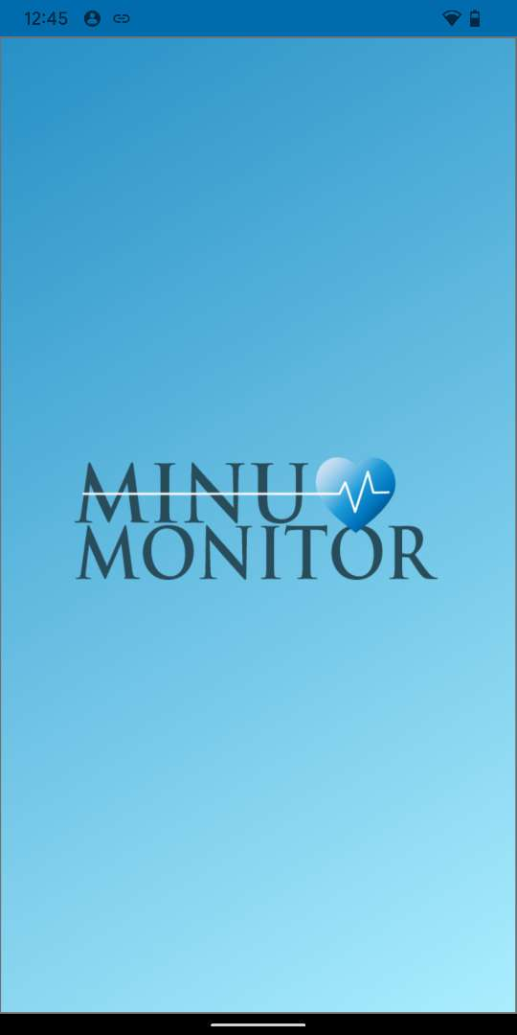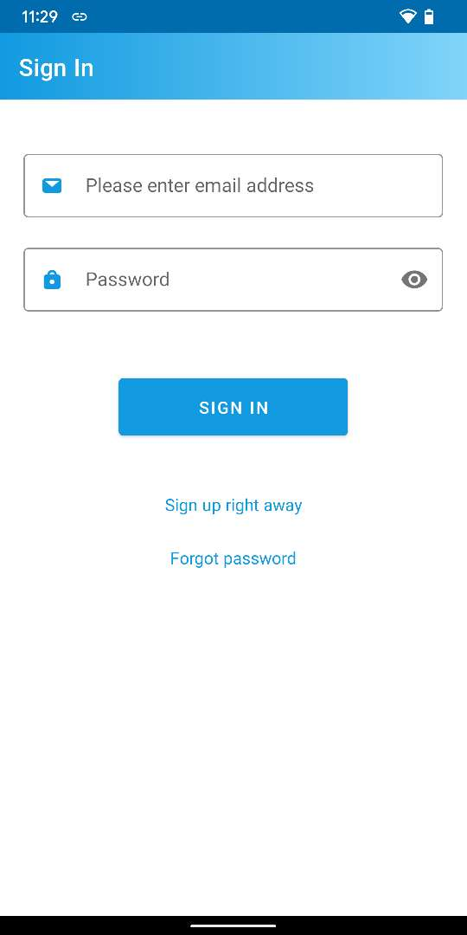

Press the App icon to launch Minu Monitor

Splash Screen

Sign in page

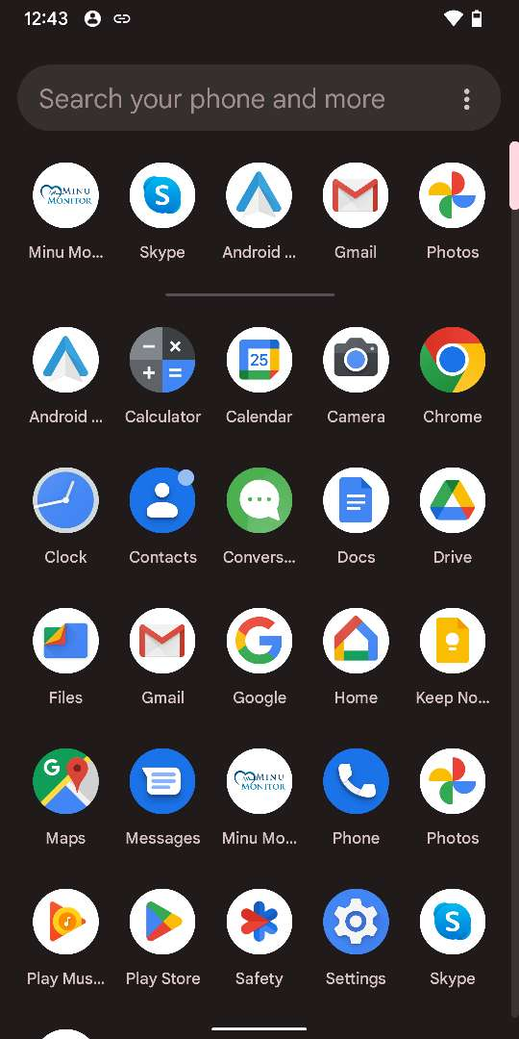

Figure ‑: Application Launching

# New Account Sign Up

***NOTE:*** ***If you already have an account, please skip the section and continue from*** ***Sign In From App*** ***section.***

“SIGN UP” page

Press on “Sign up right away”

Enter all the information

Press on “User Agreement”

Press on

“Privacy Policy”

User Agreement page

Privacy Policy page

Check the agreement

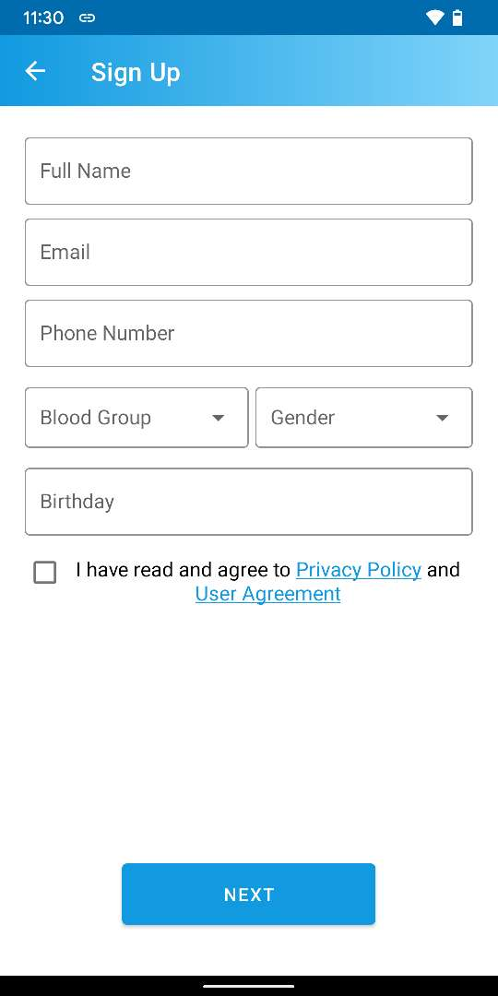

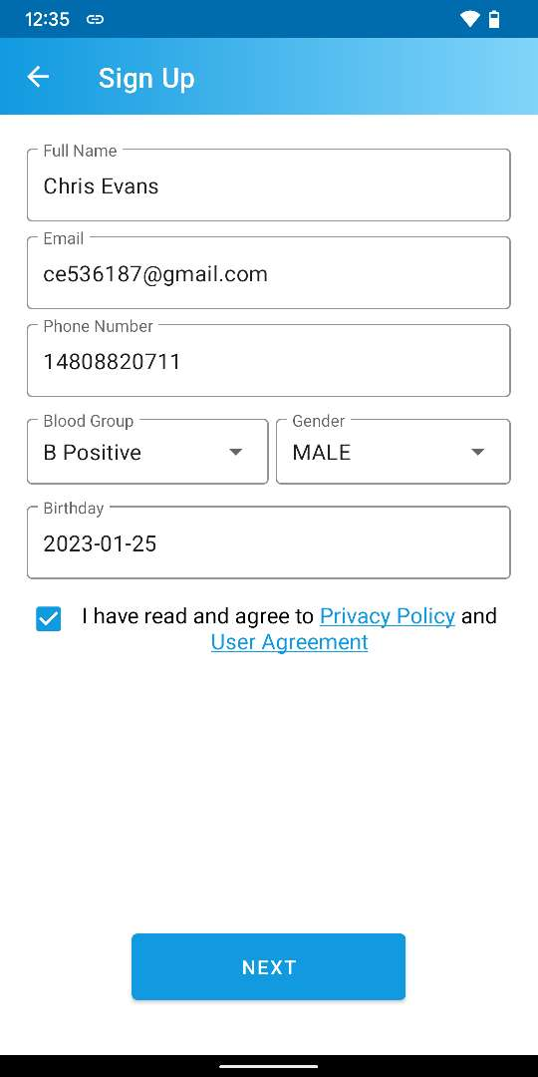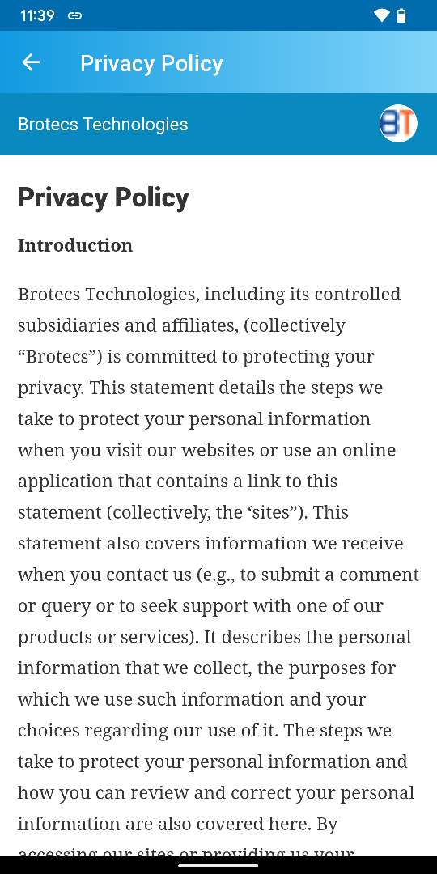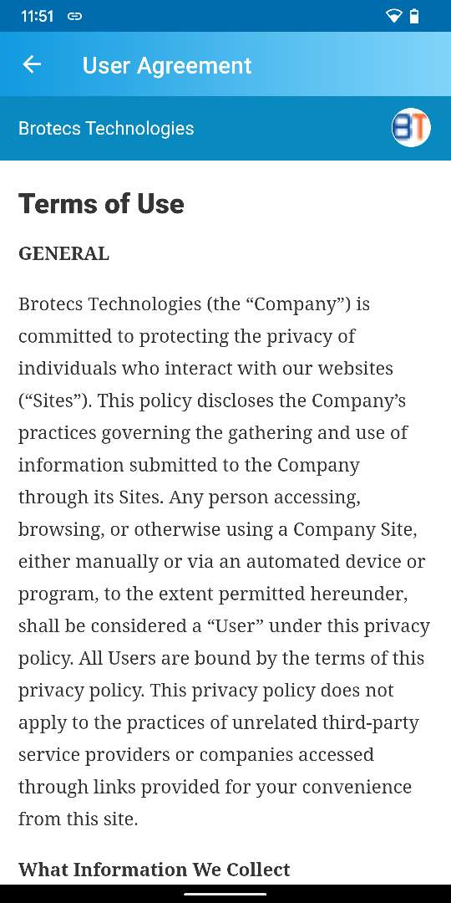

Press “NEXT” to finish Sign UP

***NOTE: Please check the agreement checkbox to continue using the app. Otherwise app will not let user perform further use of the app.***

After pressing on “NEXT” button, an email will be sent the provided email address of Sign UP page. From user email, continue complete the registration.

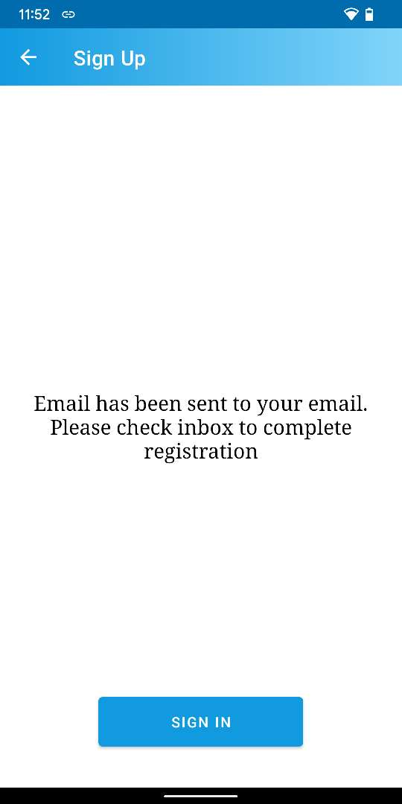

Press on “SIGN IN” button to view the Sign in page

Sign In page

Set “New Password” & “Confirm Password” and Press “Confirm”

Press “Complete Registration”

An email to create password is sent to the provided email address

Email thread of native email app

Password set successful pop up

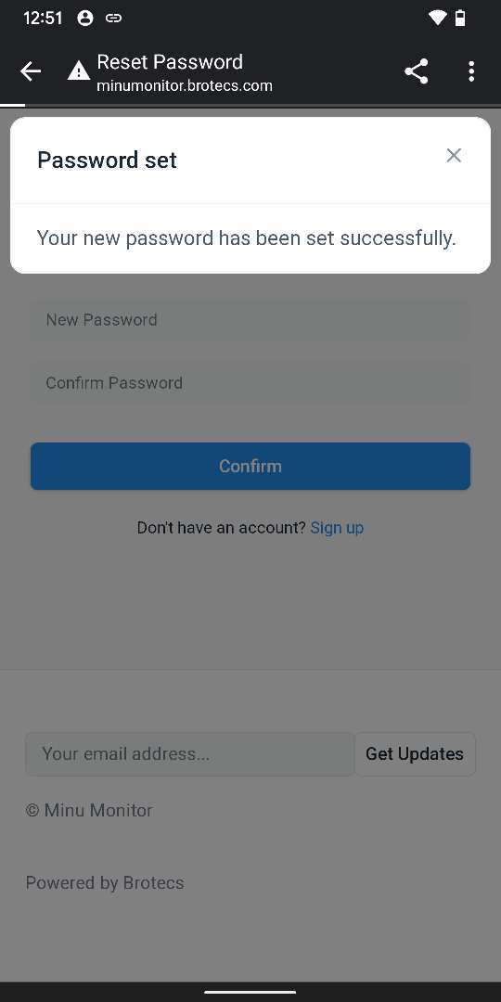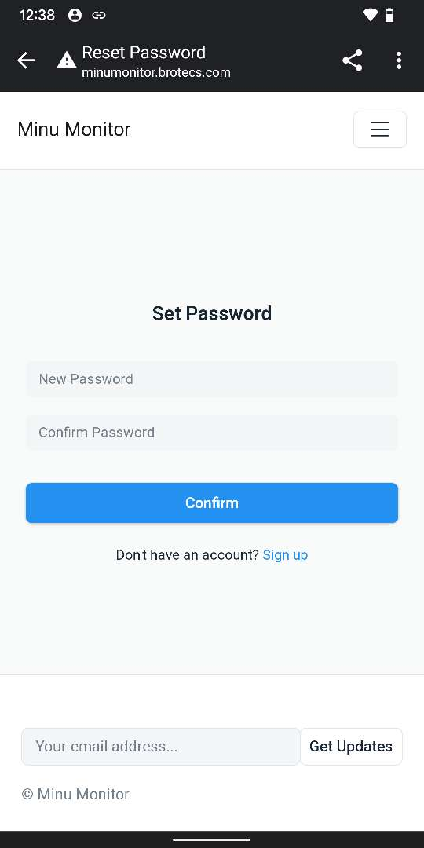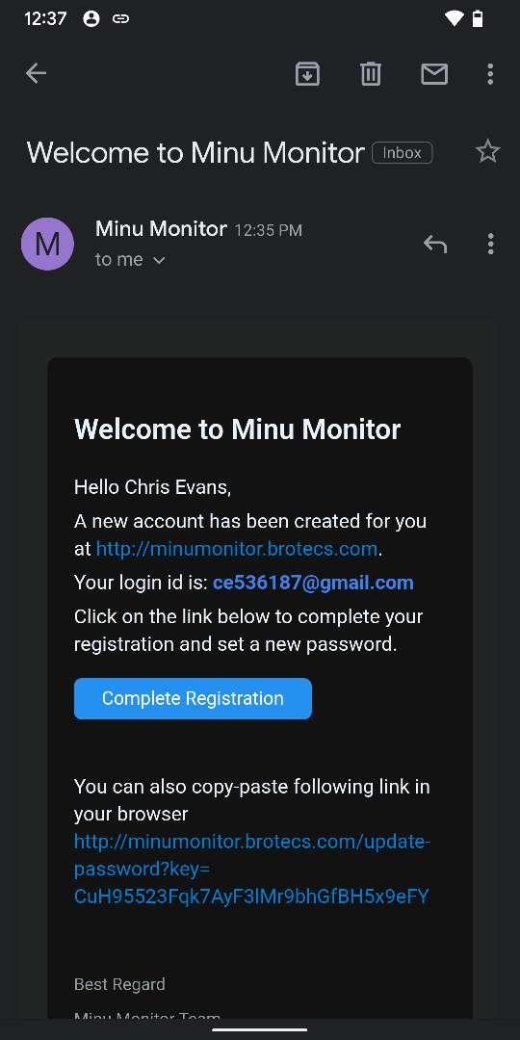

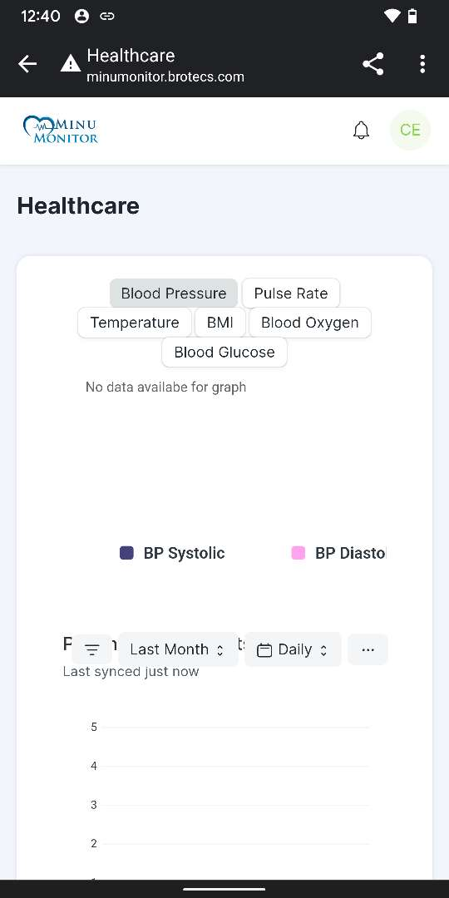

Auto signs in into Minu Monitor Web Page after completing User Registration

Figure ‑: New Account Sign Up Process

# Sign In to App

Enter “Email” & “Password” then Press on “SIGN IN” button

Seeking permission to connect nearby devices permission

Measure tab view

After successfully signing in, app navigates to “Measure” tab

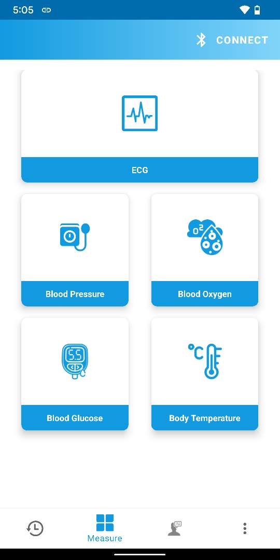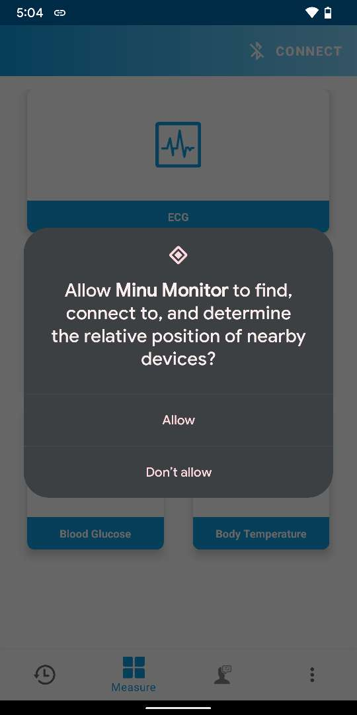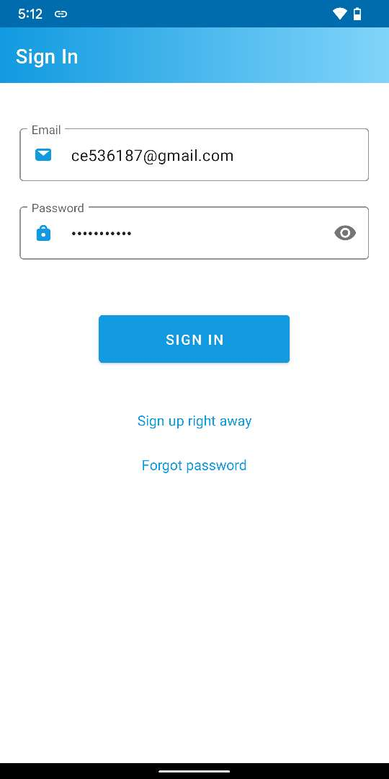

Figure ‑: Sign In Process from App

***NOTE: A user can sign in to Minu Monitor web page with the same credentials as well. To view the web page please review the*** ***How to Login Minu Monitor web as a Patient*** ***section of*** ***Appendix A******.***

# Connect And Disconnect

To measure and view any Chronic condition, User needs to connect Vital Signs Monitor device with Minu Monitor app.

## How to Connect Vital Signs Monitor Device to App

Press to initiate connecting Vital Signs Monitor Device

Seeking permission to access device location

Press “Connect” again

Shows a Pop Up for Scanning Vital Signs Monitor Device

Shows nearby founded Vital Signs Monitor Device list. Select device from here.

Press to connect the selected

Vital Signs Monitor Device device

Shows “Connecting…” status

Updated connection status

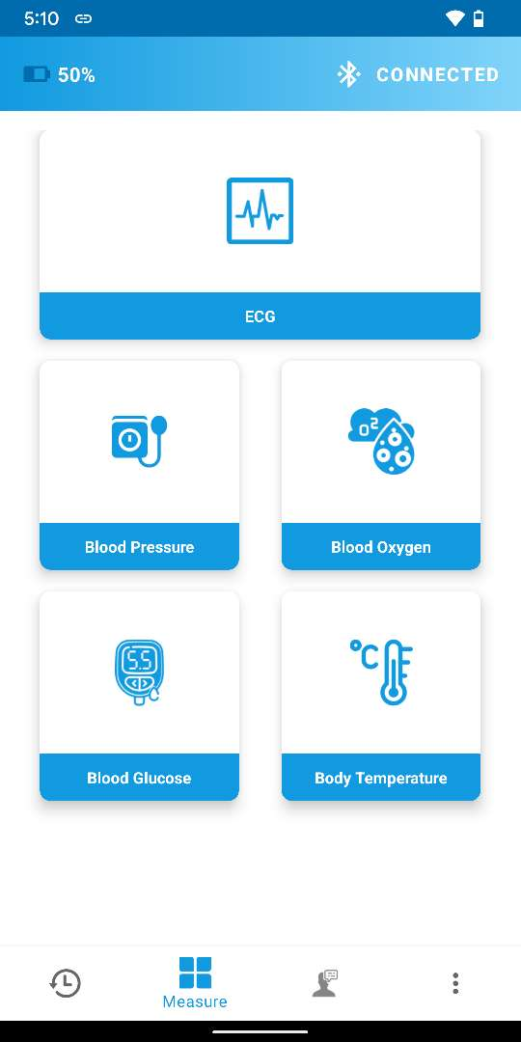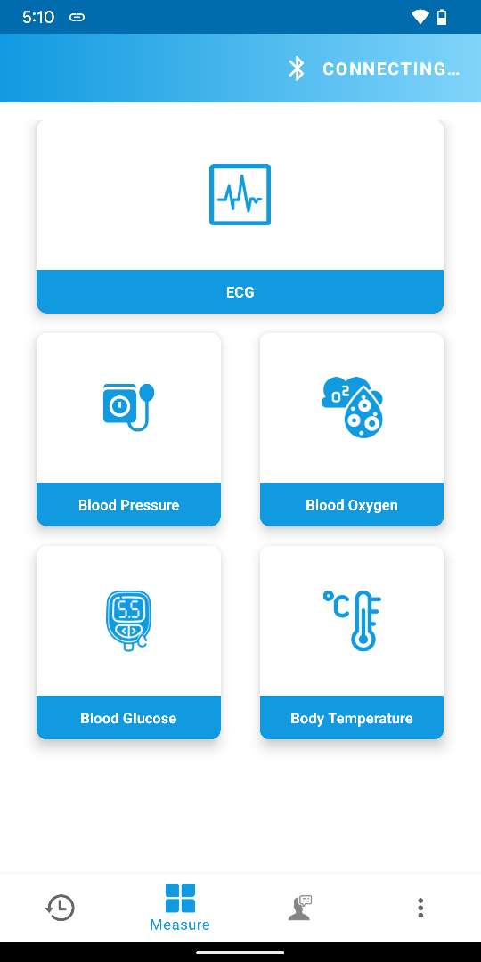

Shows battery status of connected Vital Signs Monitor Device

Figure ‑: Connect Vital Signs Monitor Device with App

***NOTE: Location permission is mandatory for showing the nearby device list. If allowed for the first time during Connecting a device, it will not be shown again.***

## How to Disconnect Vital Signs Monitor Device From App

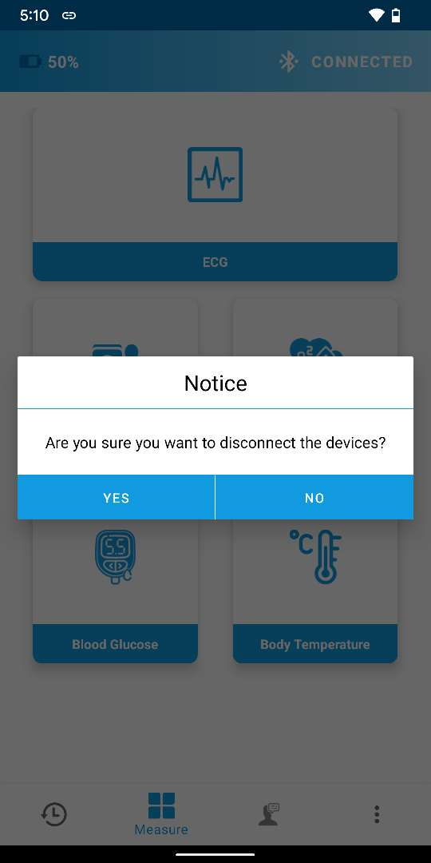

Press “CONNECTED” button to initiate disconnecting the device.

Press “Yes” to disconnect the device

Device disconnected alert message.

Press “OK”

Shows “CONNECT” button since no device is connected

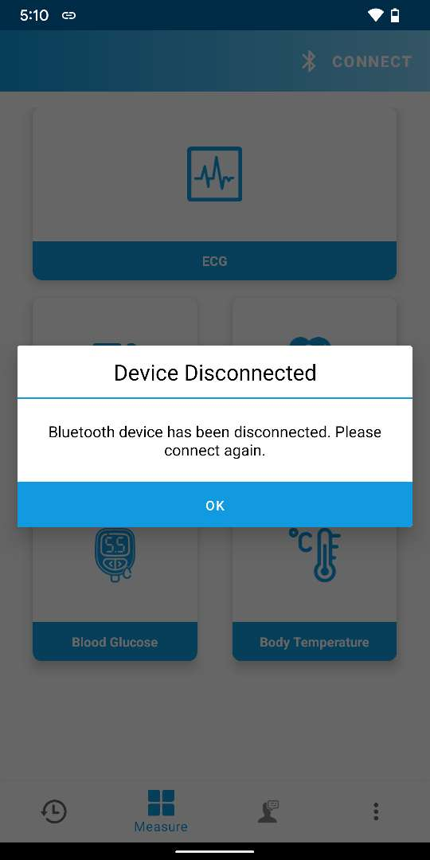

Figure ‑: Disconnect Vital Signs Monitor Device From App

# Measure

## How to measure ECG

To use the Vital Signs Monitor device during the measurement, please follow the steps of the Guidelines for ECG Measurements at the same time and continue from the App.

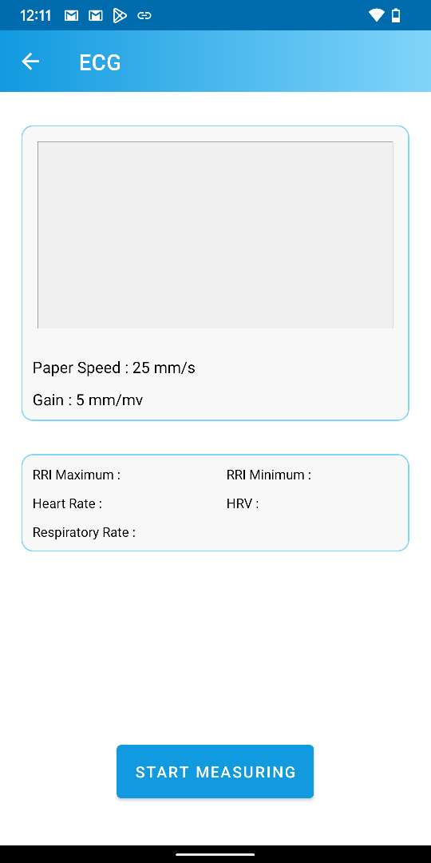

Press to measure ECG

ECG measuring started

Press to Stop measuring

Press “START MEASURING”

Shows measured ECG data

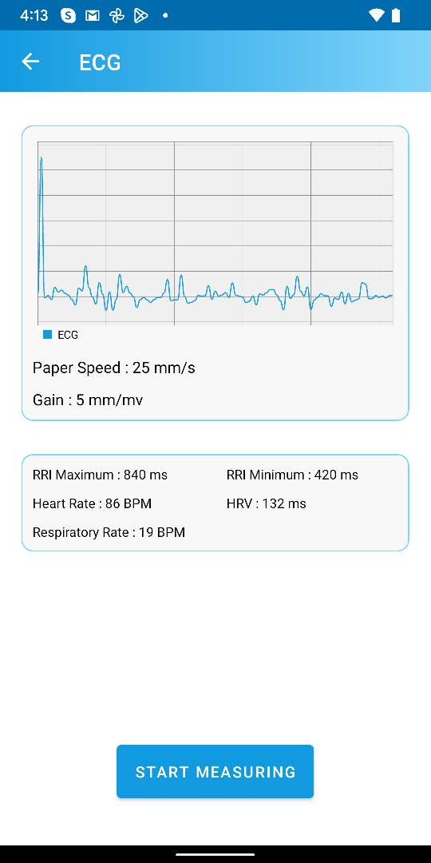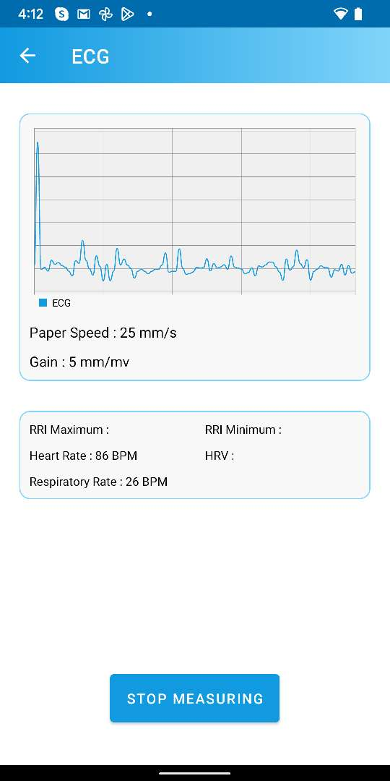

Figure ‑: Measure ECG

***NOTE: During ECG measurement, the Vital Signs Monitor device should not be disconnected from the App. Also please wait at least one minute before pressing “STOP MEASURING” to get all data properly.***

## How to measure Blood Pressure

To use the Vital Signs Monitor device during the measurement, please follow the steps of the Guidelines for Blood Pressure Measurements at the same time and continue from the App.

Press “START MEASURING”

Press to measure Blood Pressure

Shows measured Blood Pressure data

Blood Pressure measuring started

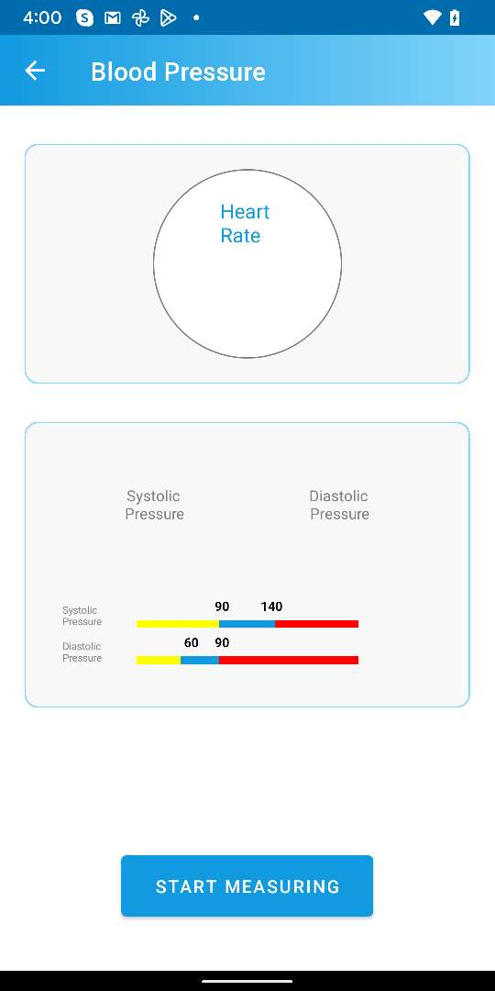

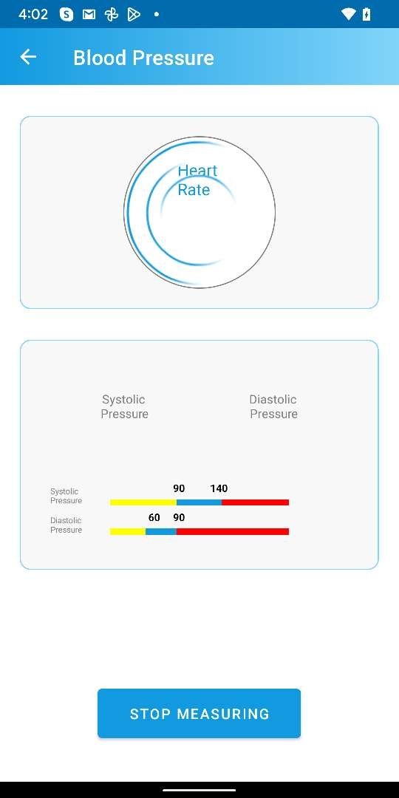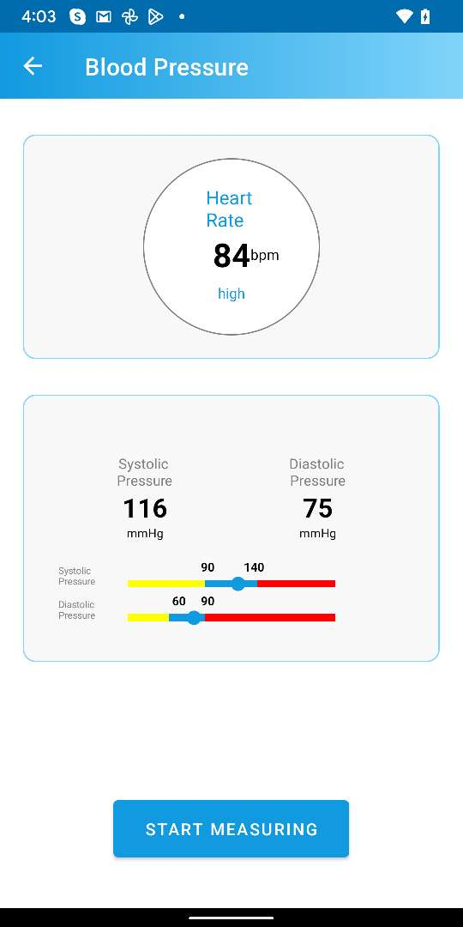

Figure ‑: Measure Blood Pressure

***NOTE: During Blood Pressure measurement, the Vital Signs Monitor device should not be disconnected from the App.***

## How to measure Blood Oxygen

To use the Vital Signs Monitor device during the measurement, please follow the steps of the Guidelines for Blood Oxygen Measurements at the same time and continue from the App.

Press “START MEASURING”

Shows measured Blood Oxygen data

Blood Oxygen measuring started

Press to measure Blood Oxygen

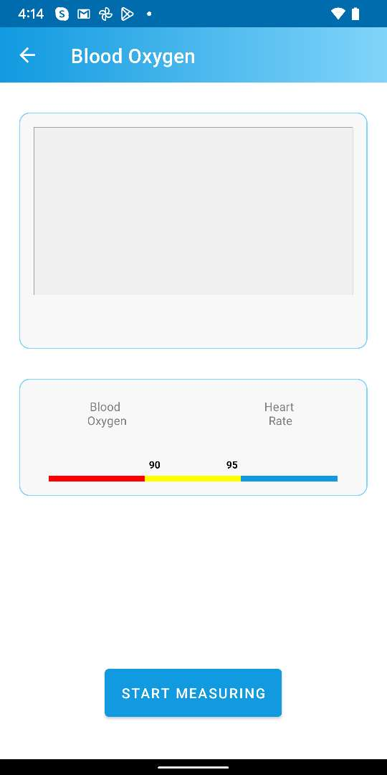

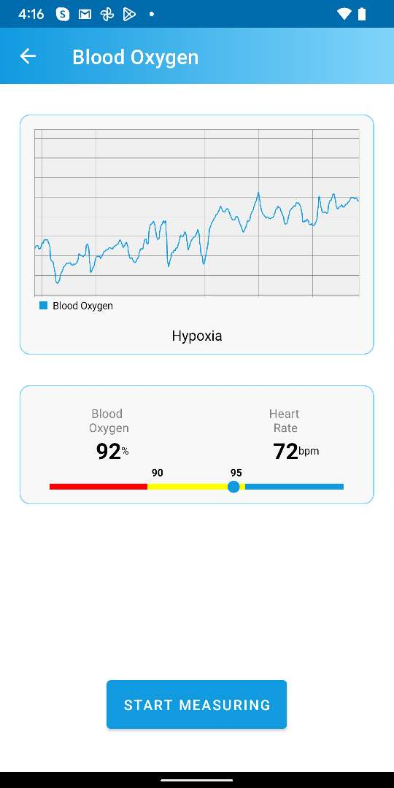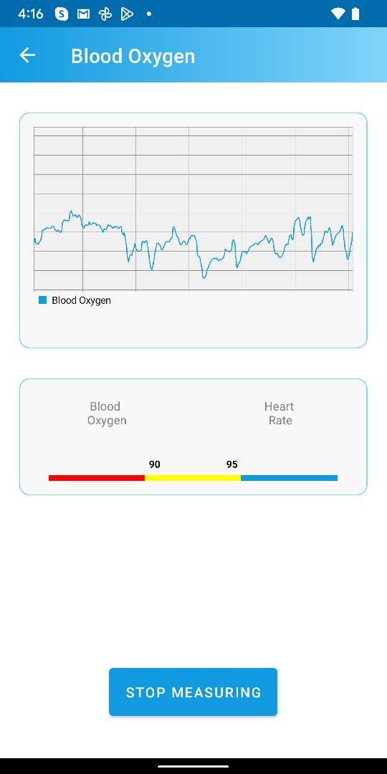

Figure ‑: Measure Blood Oxygen

***NOTE: During Blood Oxygen measurement, the Vital Signs Monitor device should not be disconnected from the App. Also please wait for few seconds to complete the measurement.***

## How to measure Blood Glucose

To use the Vital Signs Monitor device during the measurement, please follow the steps of the Guidelines for Blood Glucose Measurements at the same time and continue from the App.

Press “START MEASURING”

Shows measured Blood Glucose data

Press to measure Blood Glucose

Insert blood glucose test strip into the device

Showing error as blood glucose test strip is not inserted

Blood glucose test strip is inserted properly

Showing Blood sample collected status after adding blood sample in the strip

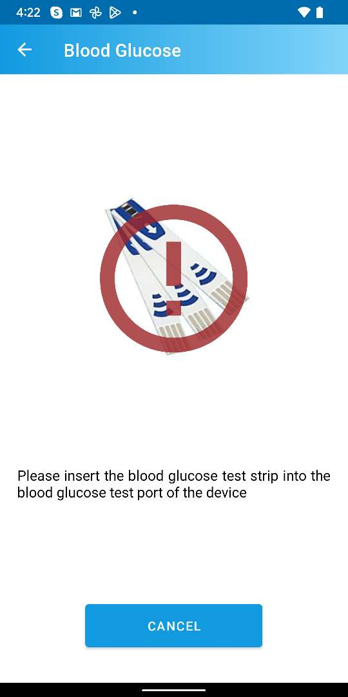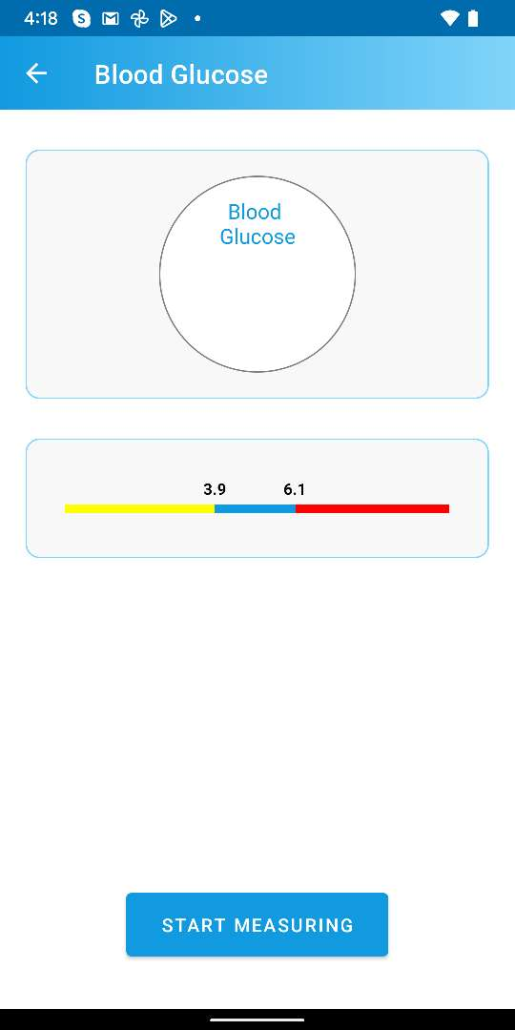

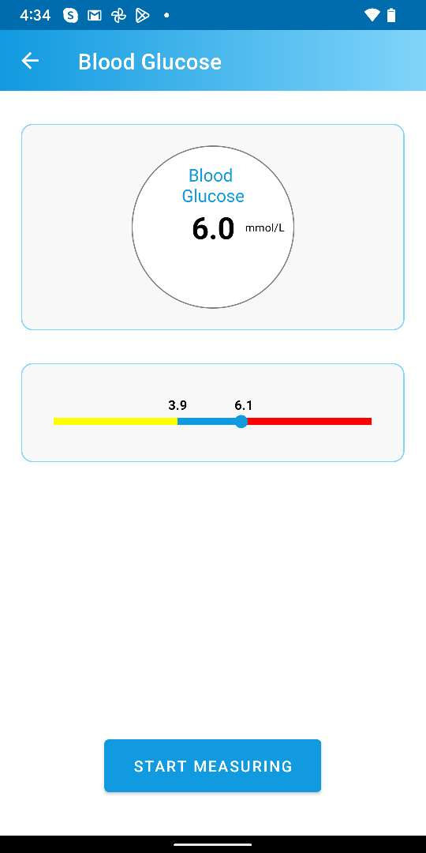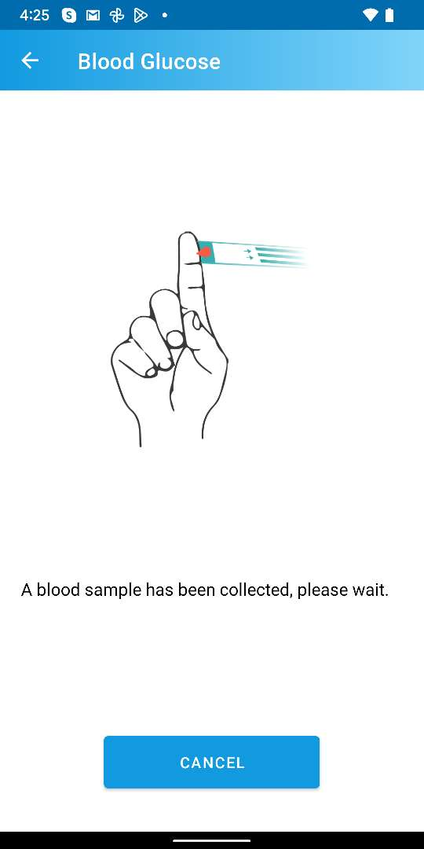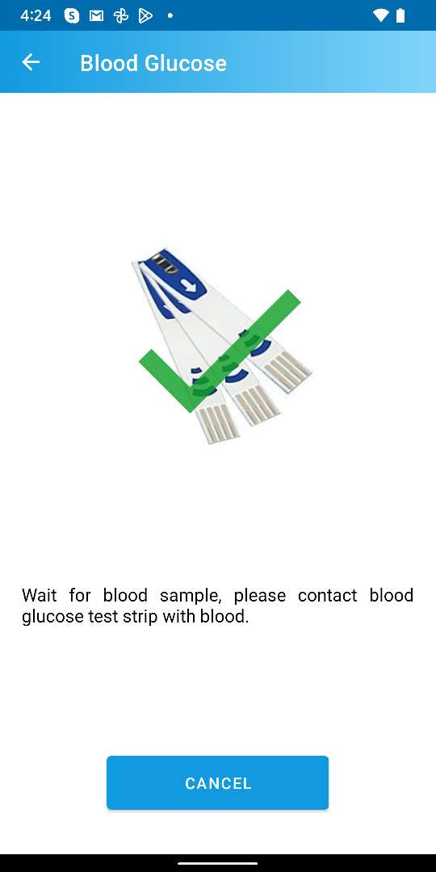

Figure ‑: Measure Blood Glucose

***NOTE: During Blood Glucose measurement, the Vital Signs Monitor device should not be disconnected from the App. Also please wait for few seconds after putting blood sample on the test strip to calculate the Blood Glucose data.***

## How to measure Body Temperature

To use the Vital Signs Monitor device during the measurement, please follow the steps of the Guidelines for Body Temperature Measurements at the same time and continue from the App.

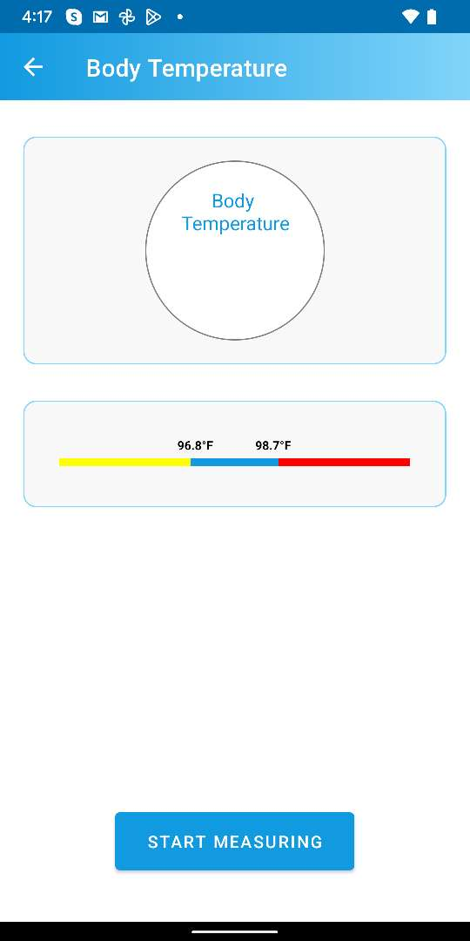

Press “START MEASURING”

Shows measured Body Temperature data

Body Temperature measuring started

Press to measure Body Temperature

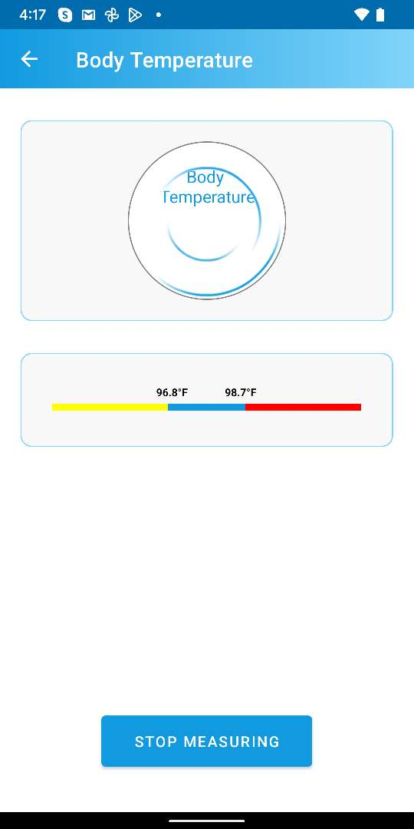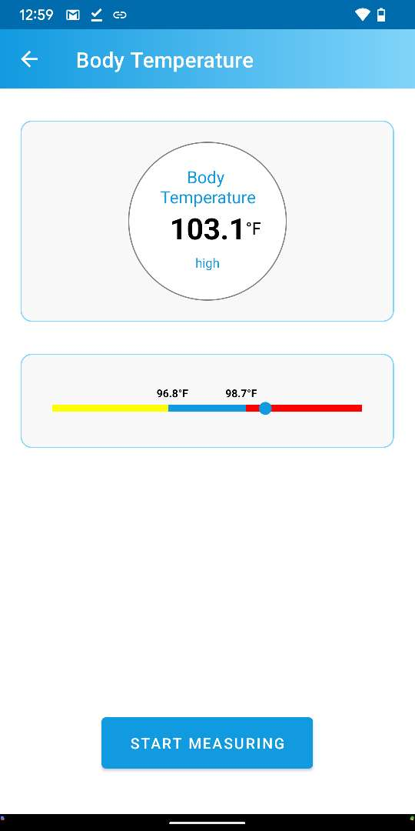

Figure ‑: Measure Body Temperature

***NOTE: During Body Temperature measurement, the Vital Signs Monitor device should not be disconnected from the App.***

# Record

The “Record” section shows all the records of vital sign measurements. The section gets auto synced with server. However, a user can manually sync data from server whenever desired.

Press to view “Record” tab

Shows “Record” tab

Press to sync data from server

Loading data

Shows up to date data

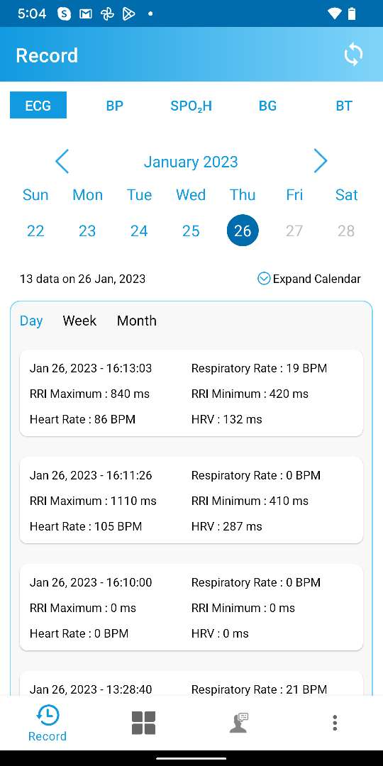

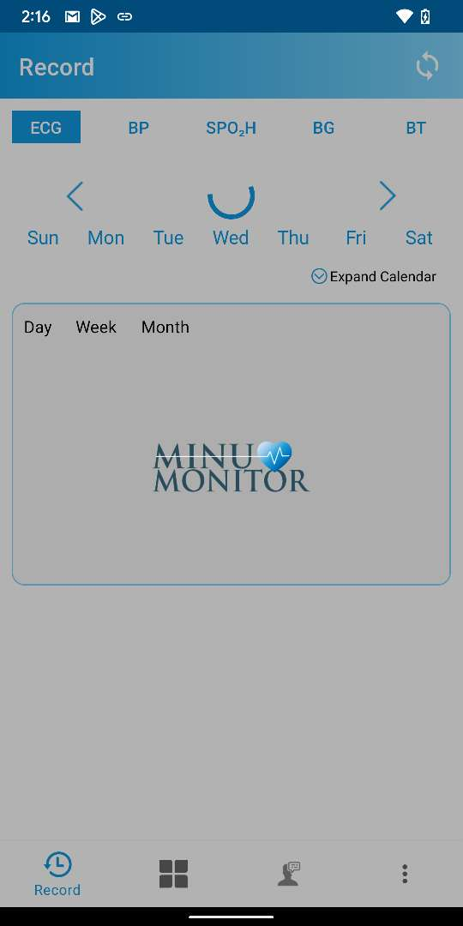

Figure ‑: Record tab

***NOTE: Vital records can be seen as daily, weekly or monthly patterns. To view, please press on the “Day”, “Week”, “Month” options.***

***NOTE: A user can view the Vital Sign records from Minu Monitor web page as well. Please review the section*** ***Vital records in Healthcare*** ***of*** ***Appendix A*** ***to learn more.***

## ECG Record

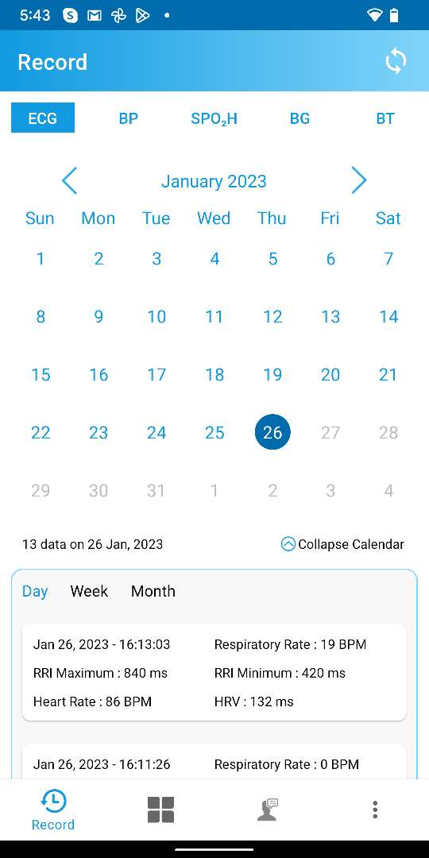

Press “ECG” to view ECG measurement records

Showing ECG records for each day

Press to expand calendar

Press to collapse calendar

Figure ‑: ECG record

## Blood Pressure Record

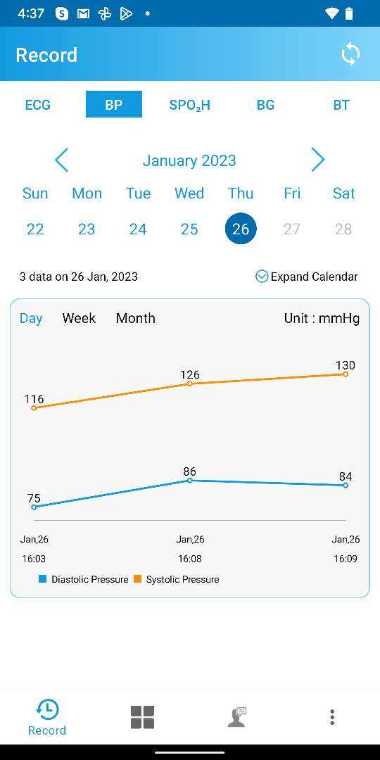

Press “BP” to view Blood Pressure measurement records

Showing Blood Pressure records for each day

Figure ‑: Blood Pressure record

## Blood Oxygen Record

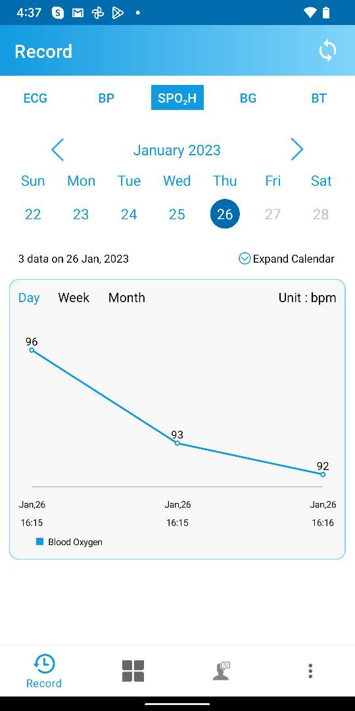

Press “SPH” to view Blood Oxygen measurement records

Showing Blood Oxygen records for each day

Figure ‑: Blood Oxygen record

## Blood Glucose Record

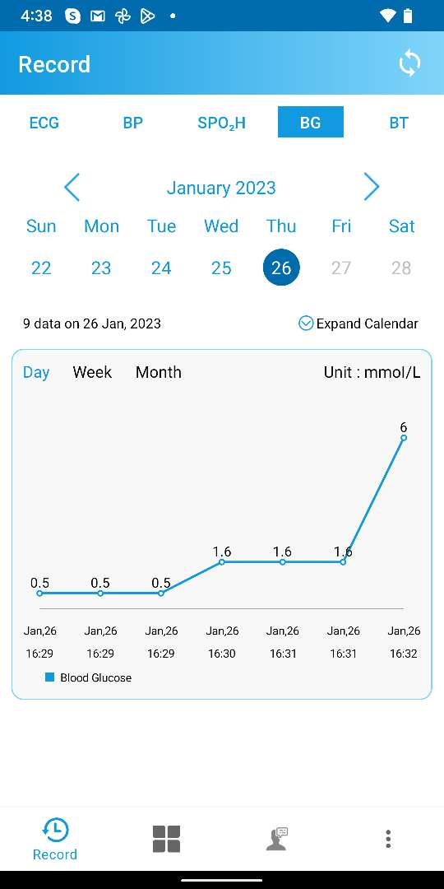

Press “BG” to view Blood Glucose measurement records

Showing Blood glucose records for each day

Figure ‑: Blood Glucose record

## Body Temperature Record

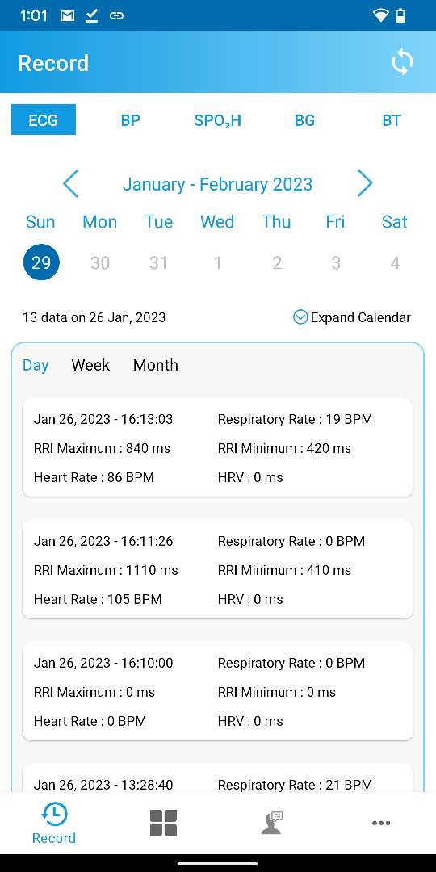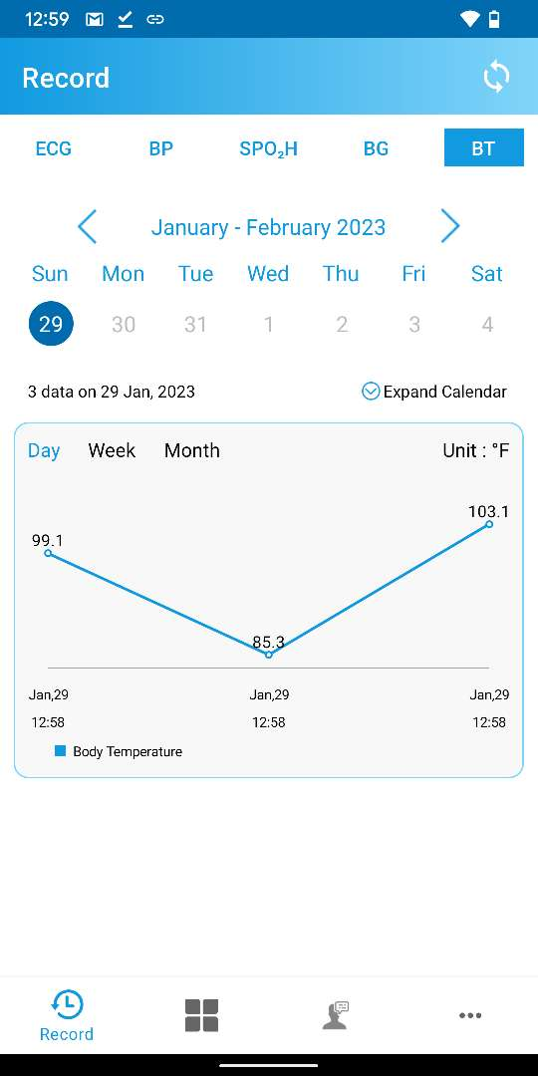

Press “BT” to view Body Temperature measurement records

Showing Body Temperature records for each day

Figure ‑: Body Temperature record

# Appointment

From Appointment tab, a user can add and view appointments.

Press to open Appointment tab

Shows Appointment tab

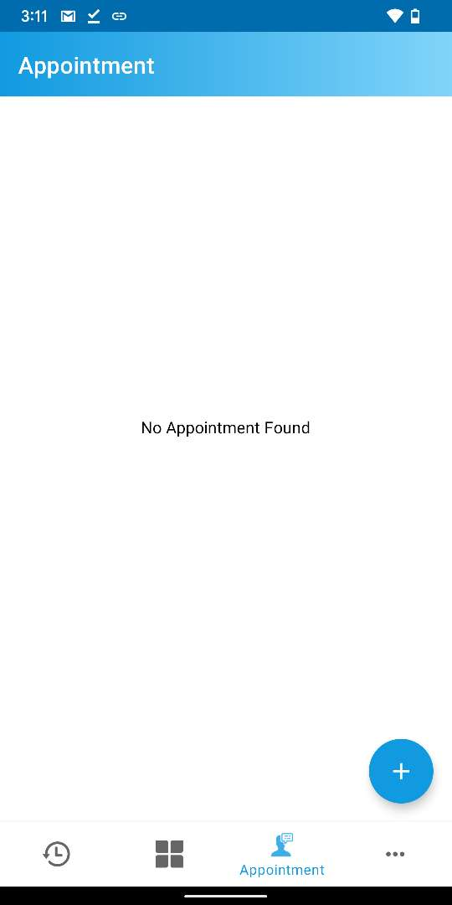

Figure ‑: Appointment tab

## Add a new Appointment

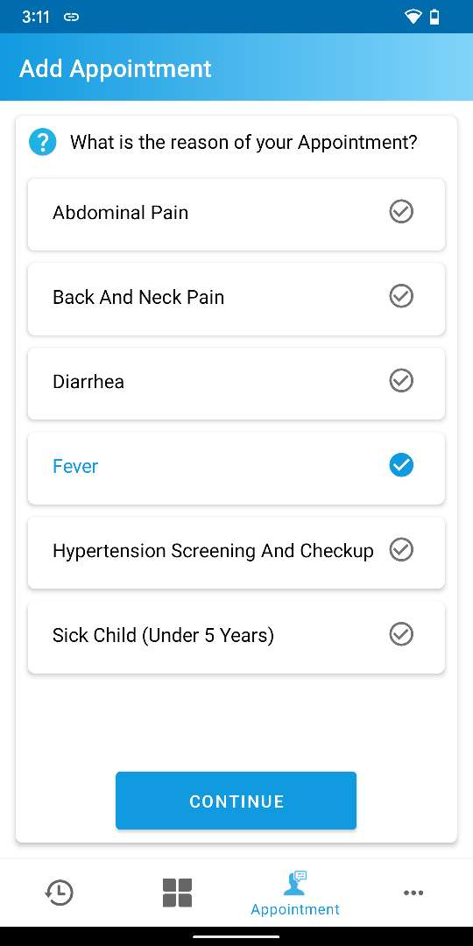

Select Any Reason and Press “CONTINUE”

Press “+” Icon to add an Appointment

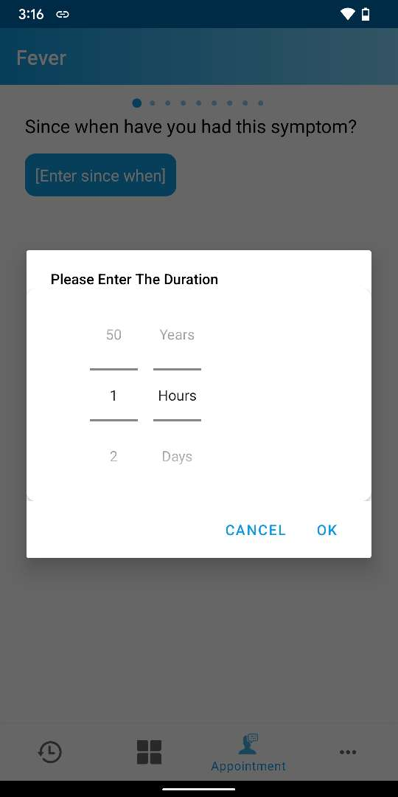

Enter all the information and Press “NEXT”

Select duration and press “OK”

Press to enter duration

Duration added

Select corresponding value from the list and swipe to the next slide

Swipe to go to next slide

Select corresponding value from the list and swipe to the next slide

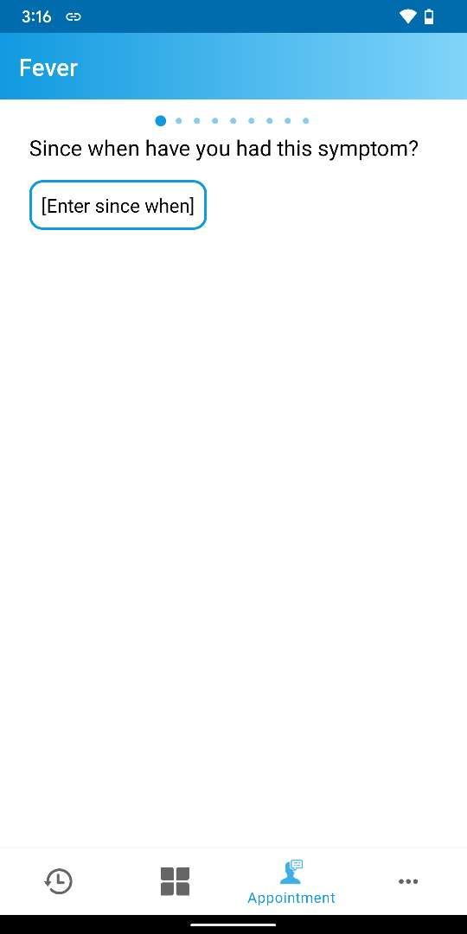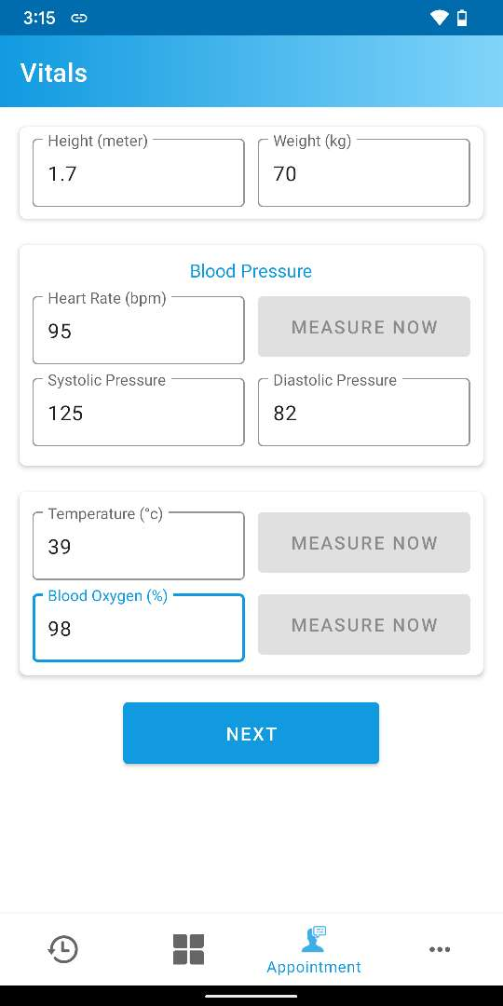

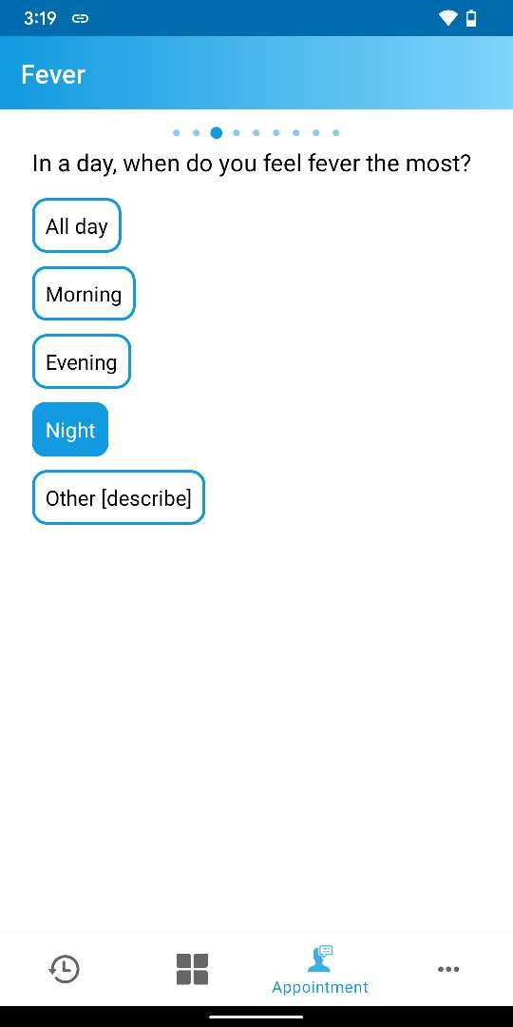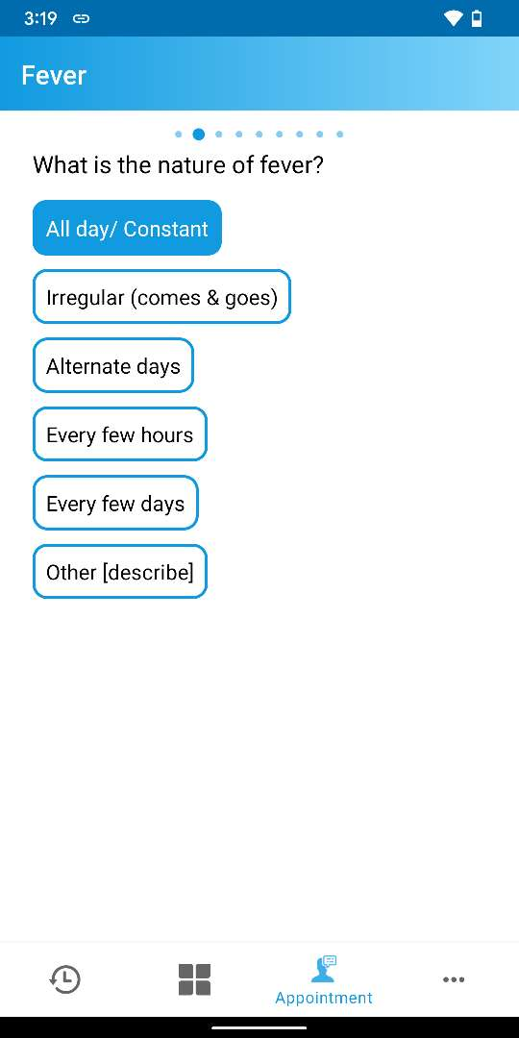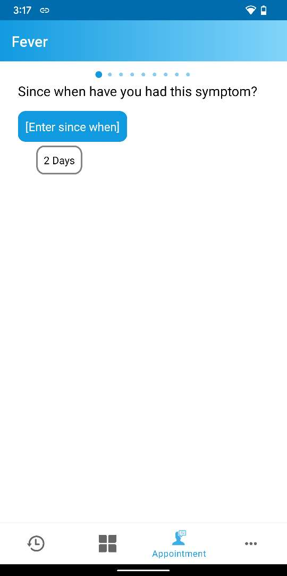

***NOTE: Multiple values can be selected in few slides.***

Press to enter information

Select corresponding value from the list and swipe to the next slide

Select corresponding values from the list and swipe to the next slide

Enter information and press to complete adding the new appointment

Appointment added

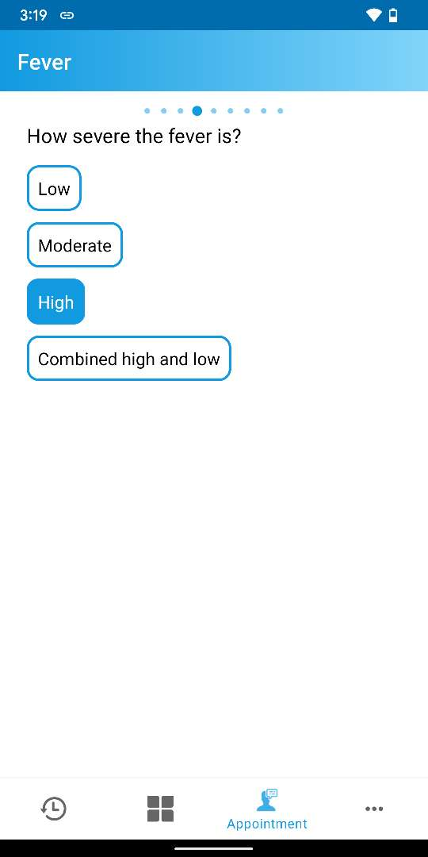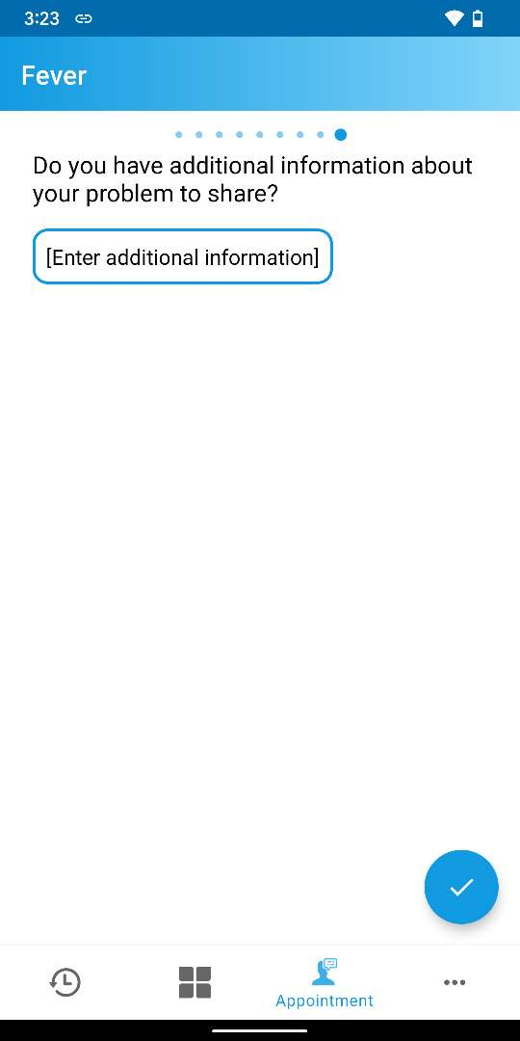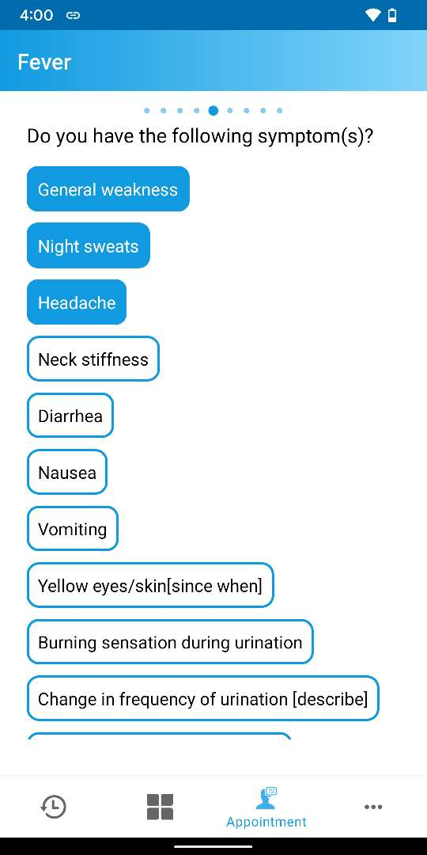

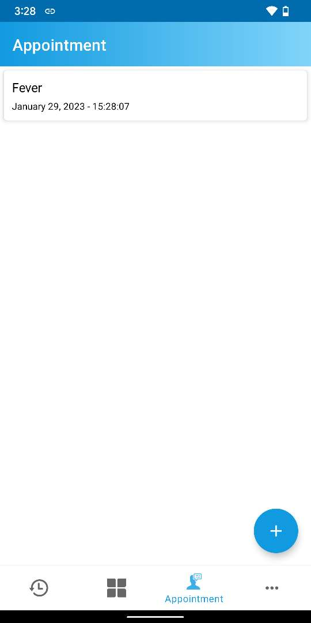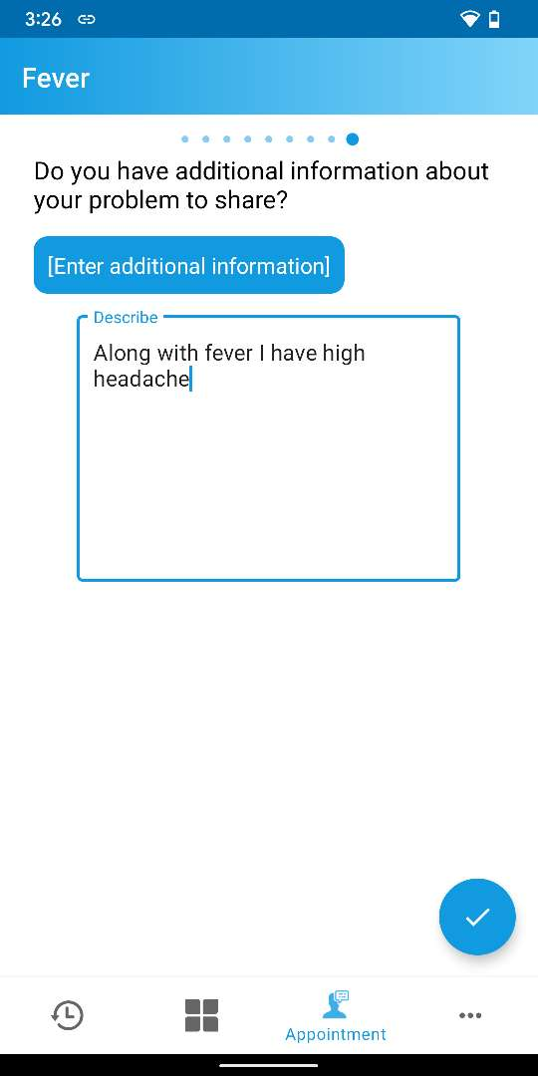

Figure ‑: Adding an appointment

***NOTE: Slides may vary according to symptoms and user inputs. User should enter information or select values as prompted then press “NEXT” button or swipe to the next slides respectively to complete creating any appointment.***

***NOTE: The above values/data in screenshots are just an illustration on how the inputs can be given or values can be selected. In the same way, for other reasons (Abdominal Pain, Back And Neck Pain, Diarrhea, Hypertension Screening And Checkup and Sick Child (Under 5 Years)) an user can create new appointments.***

## Appointment list

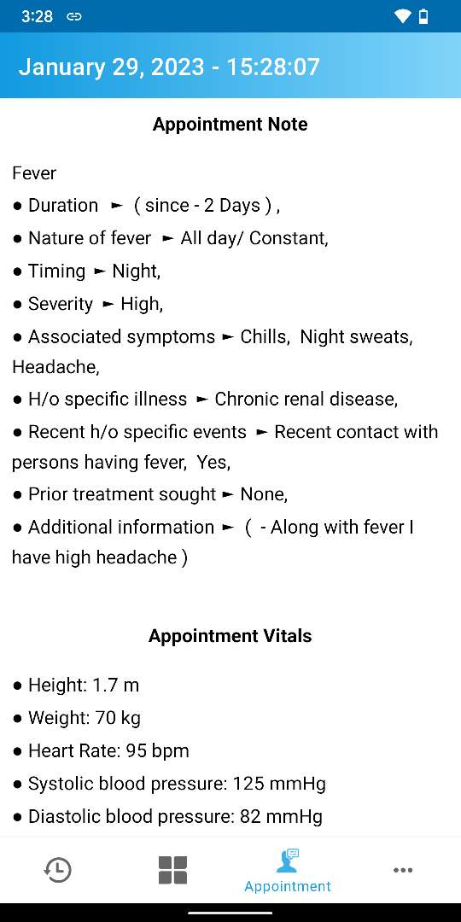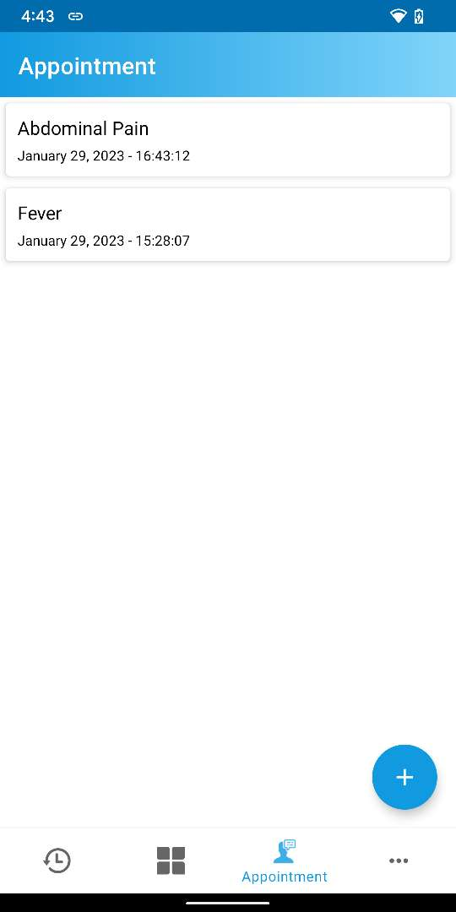

Select any appointment to view details page

Appointment details page

Figure ‑: Appointment list

***NOTE: A user can view the appointment list from Minu Monitor web page as well. Please review the section*** ***Vital Signs in Healthcare*** ***of*** ***Appendix A*** ***to learn more.***

# More

In **More** tab, a user can configure or view the following options:

|  |  |
| --- | --- |
| * Profile | * Change Password |
| * About | * Sign Out |
| * Settings |  |

Press to view More tab

Showing “More” tab

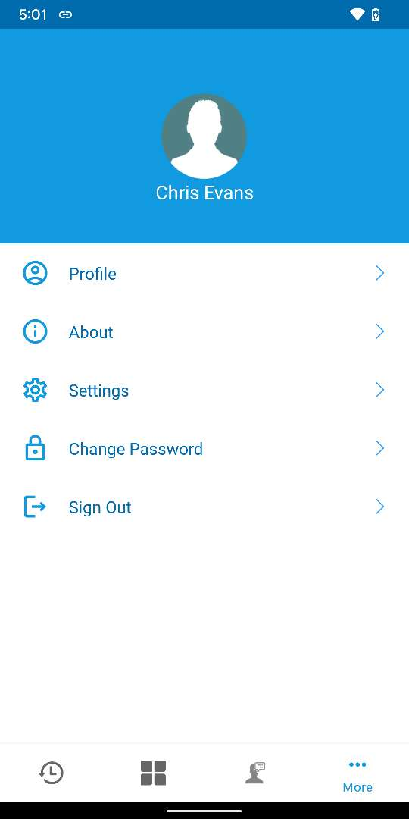

Figure ‑: More tab

## Profile

Profile is updating

Change name

Press to view “Profile” page

Press to edit profile information

Press to update profile information

Profile updated successfully

Showing updated name

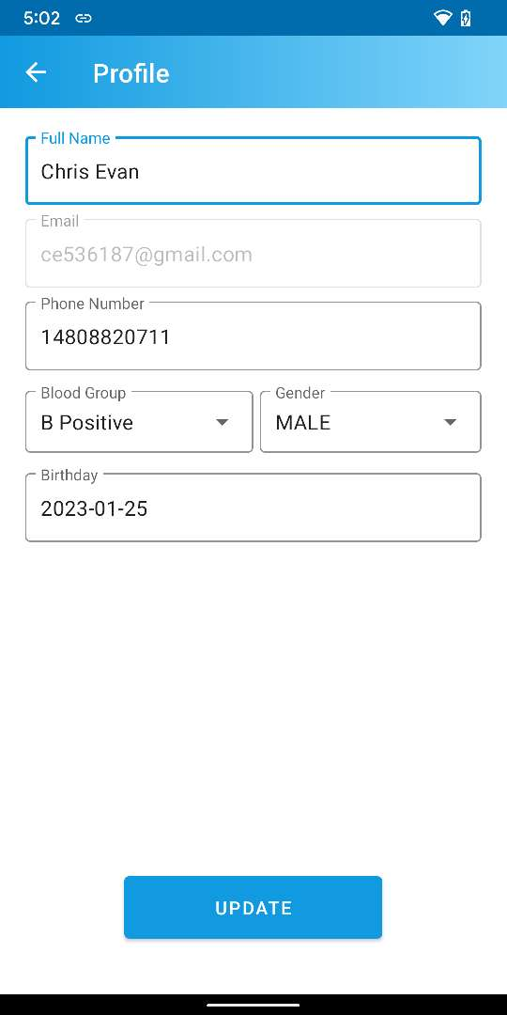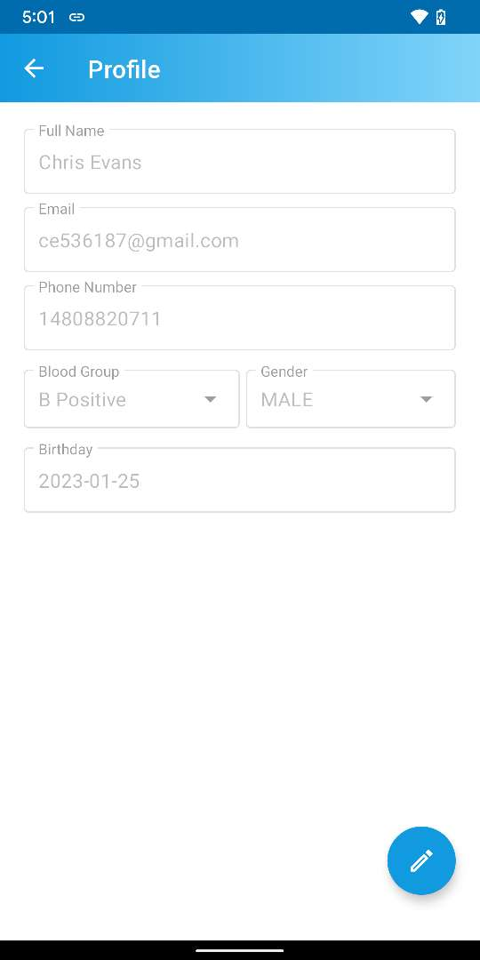

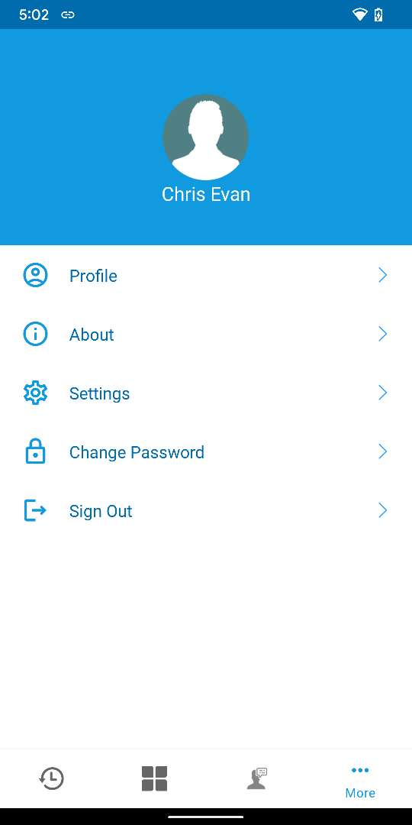

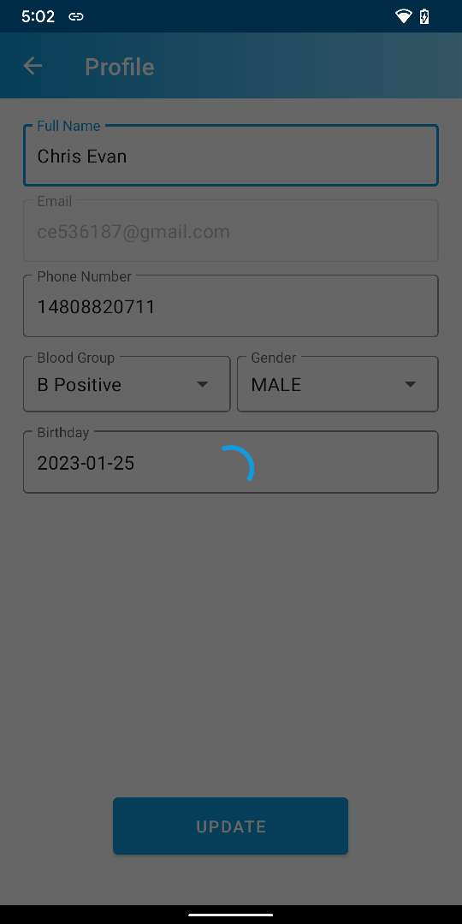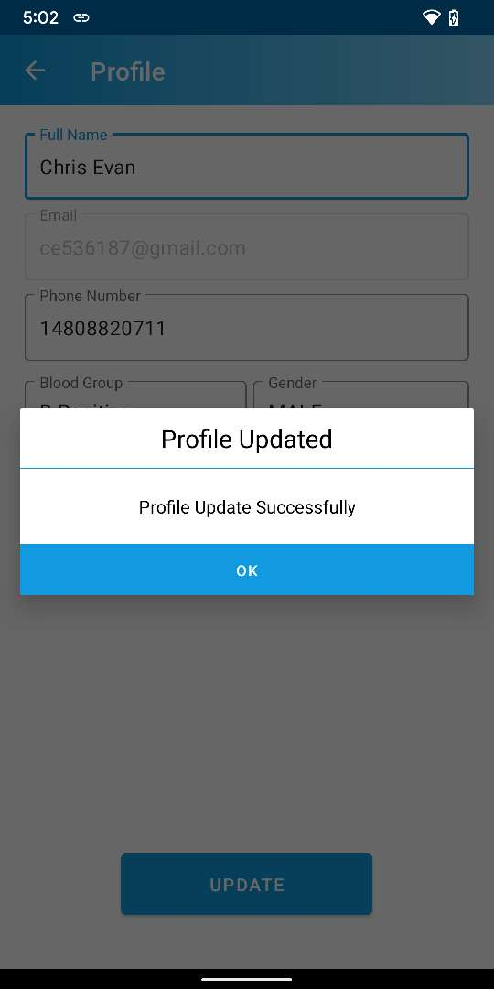

Figure ‑: Profile Update Process

## About

Press to view “About” page

Press to view Privacy Policy page

Shows “Privacy Policy” page

Shows “User Agreement”

page

Press to view User Agreement page

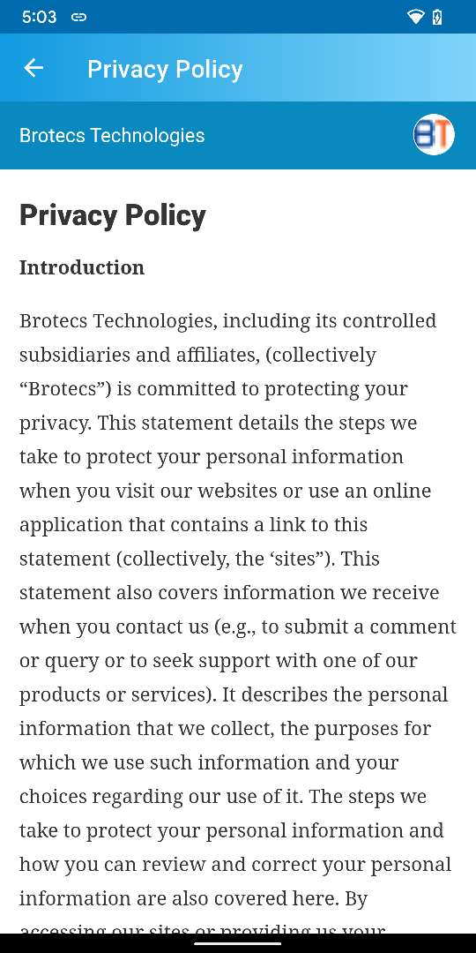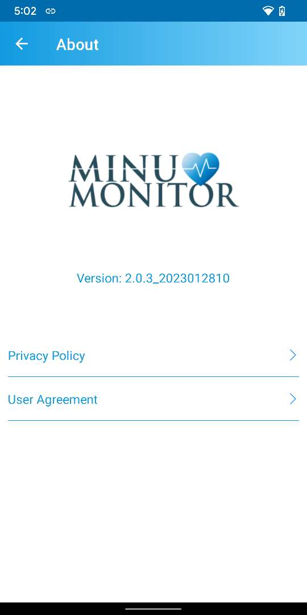

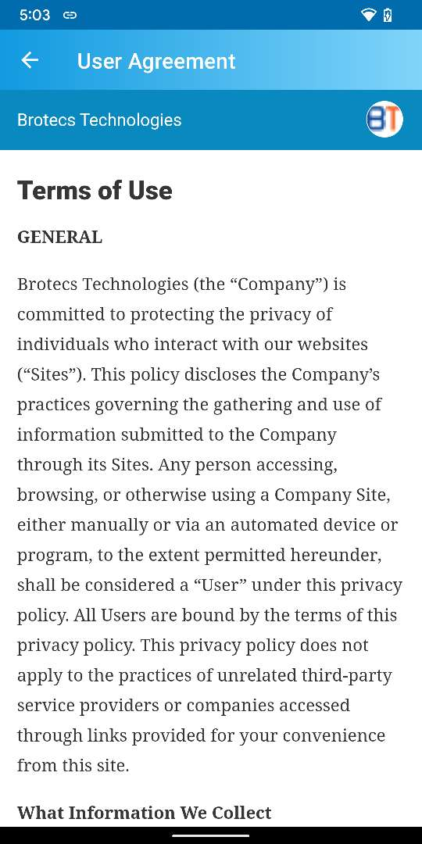

Figure ‑: About page

## Settings

In **Settings** page, a user can configure or view the following options:

|  |  |
| --- | --- |
| * Temperature | * Blood Glucose |
| * Paper Speed | * Gain |
| * Device | * Sync data from server |

Press to view Settings page

Shows Settings page

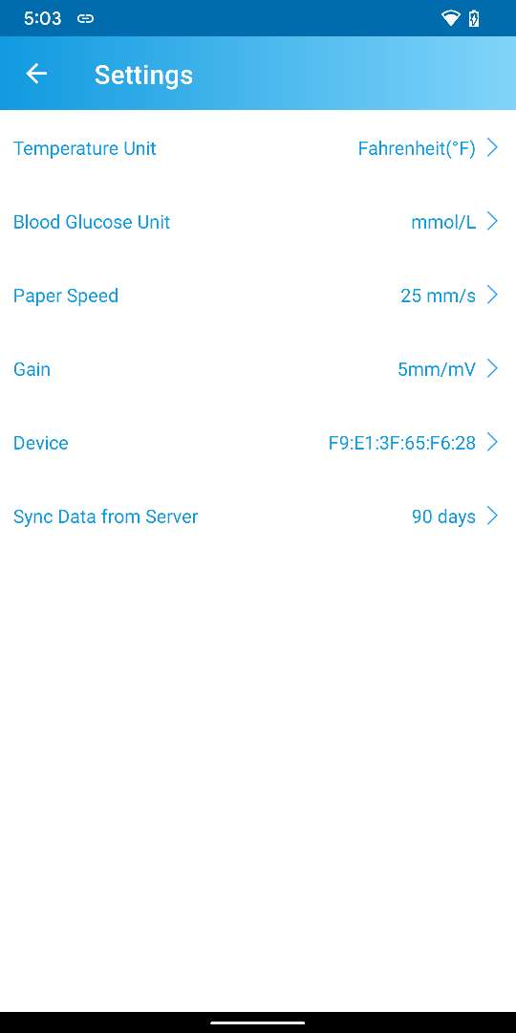

Figure ‑: Settings page

### How to change Temperature Unit

Press to change unit

Temperature Unit changed

Select unit

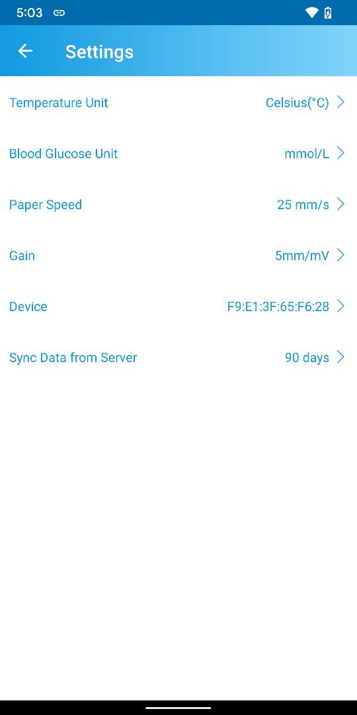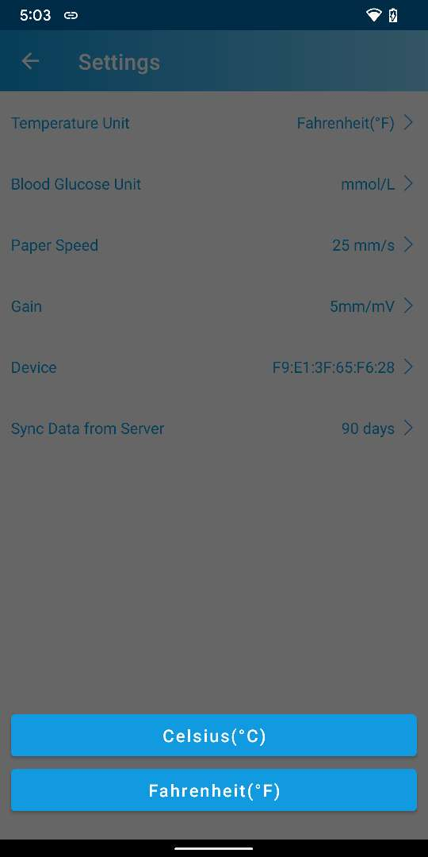

Figure ‑: Change Temperature Unit

### How to change Blood Glucose Unit

Press to change unit

Select unit

Blood Glucose Unit changed

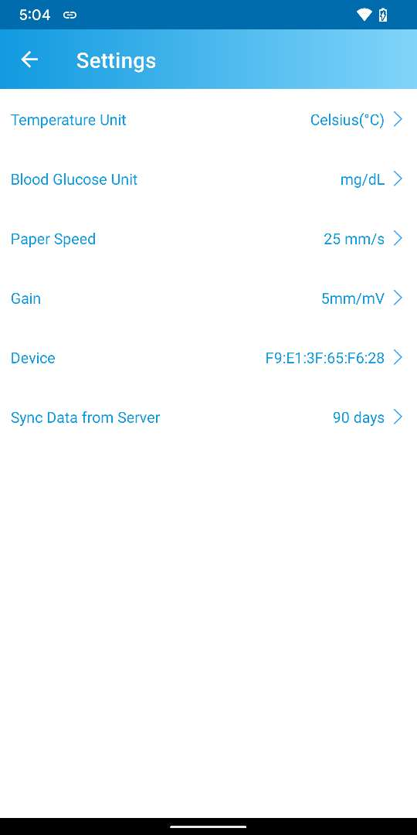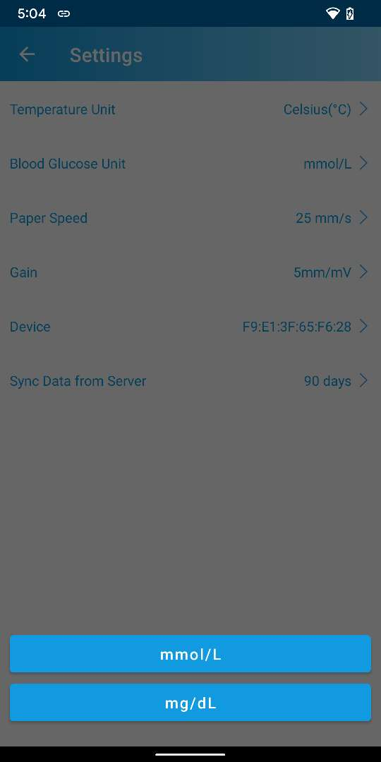

Figure ‑: Change Blood Glucose Unit

### How to change Paper Speed value

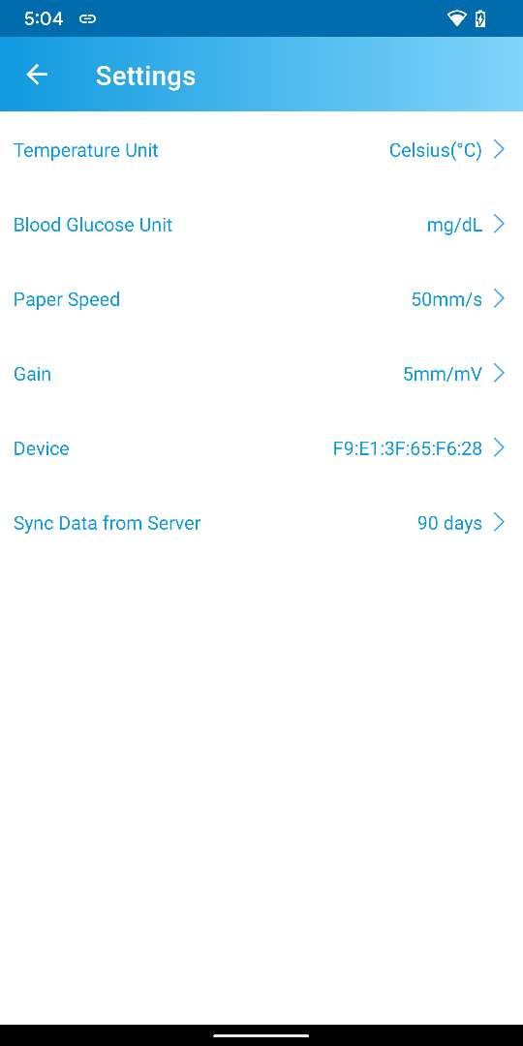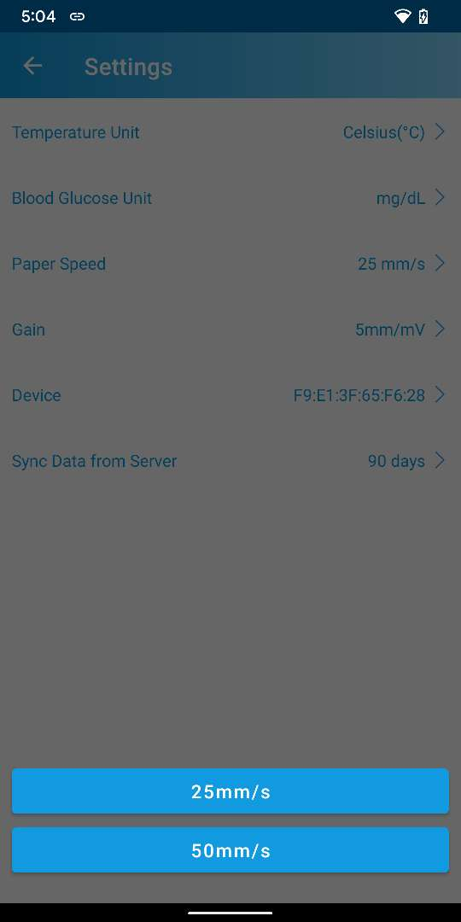

Press to change Paper Speed value

Paper speed value changed

Select speed



Figure ‑: Change Paper Speed value

### How to change Gain value

Press to change Gain value

Gain value changed

Select value

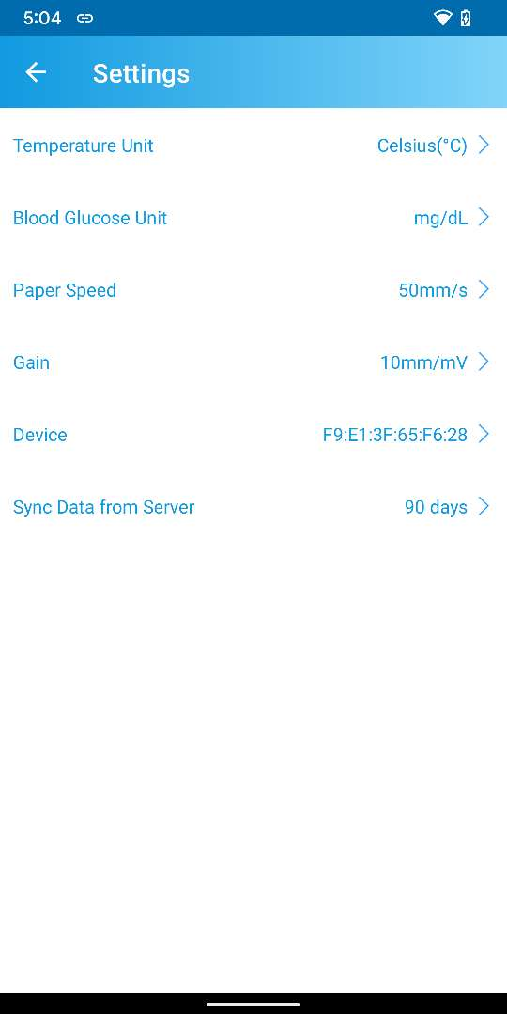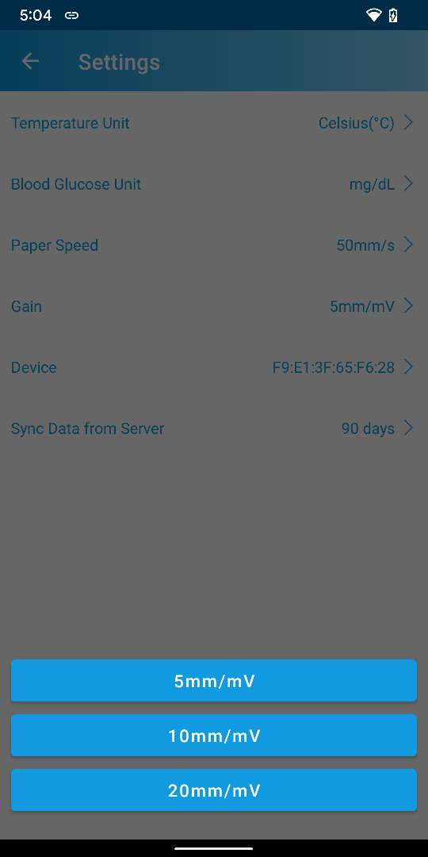

Figure ‑: Change Gain value

### How to unbind Vital Signs Monitor Device

Device is unbinded

Press “Unbind”

Press to unbind device

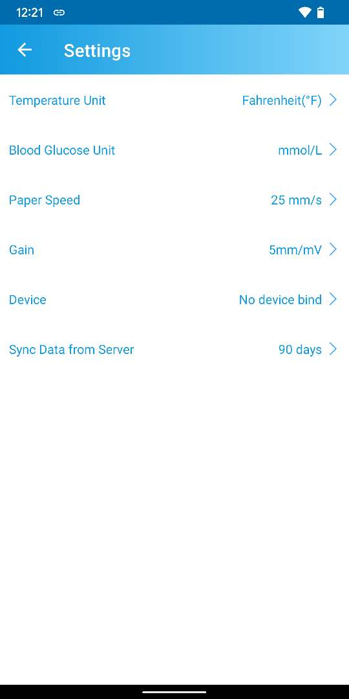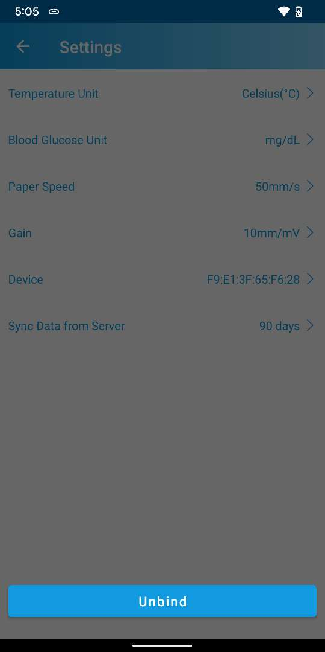

Figure ‑: Unbind Vital Sign Monitor Device

### How to change timeline to Sync Data from Server

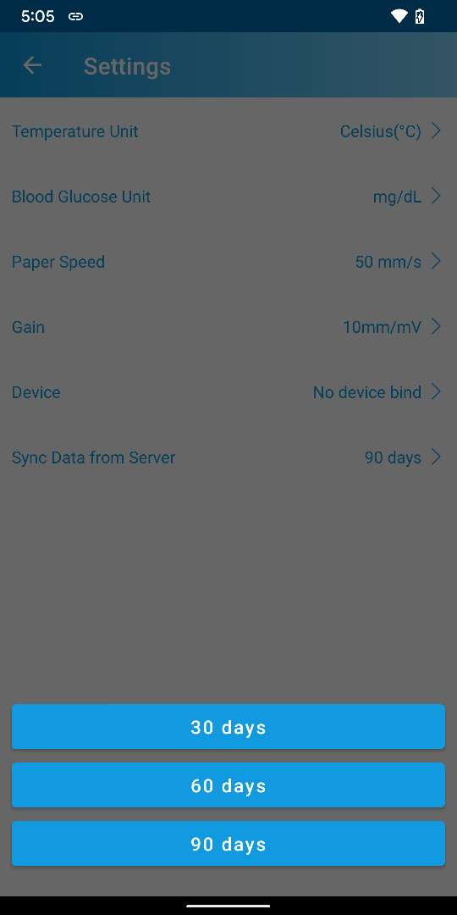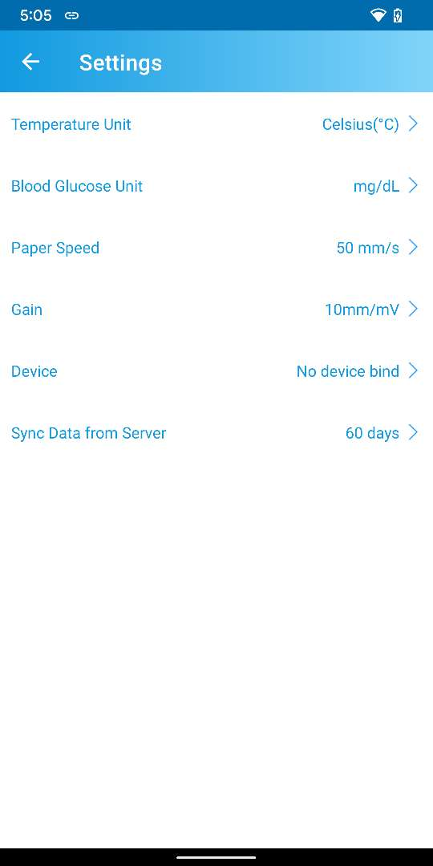

Press to change timeline

Press the timeline

Timeline changed

Figure ‑: Change timeline to Sync Data from Server

## Change Password

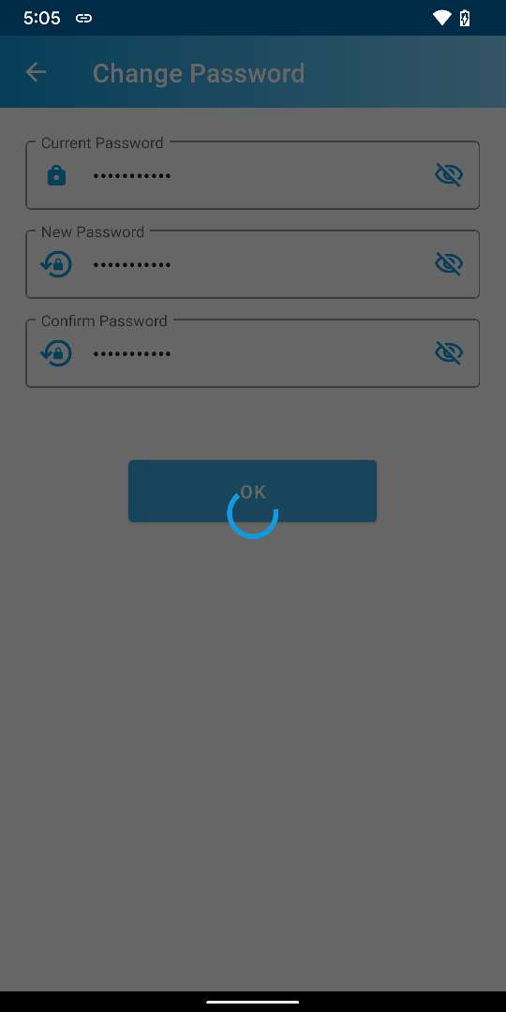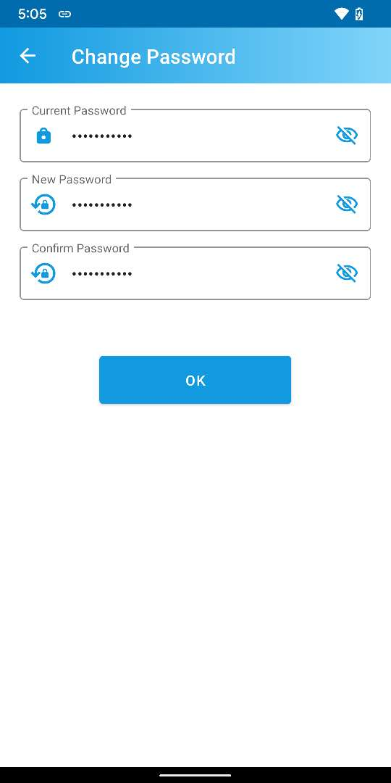

Press to Change Password

Enter passwords and Press “OK”

Password changing

Shows Change Password page

Password changed successful pop up

Press “OK”

Navigates to “More” tab

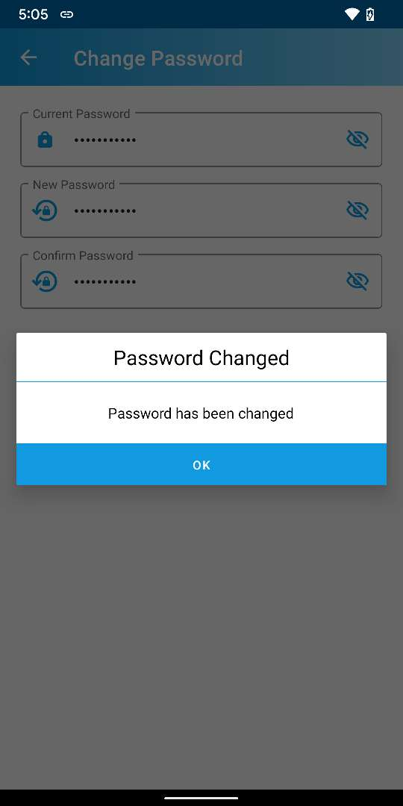

Figure ‑: Change Password

## Sign Out

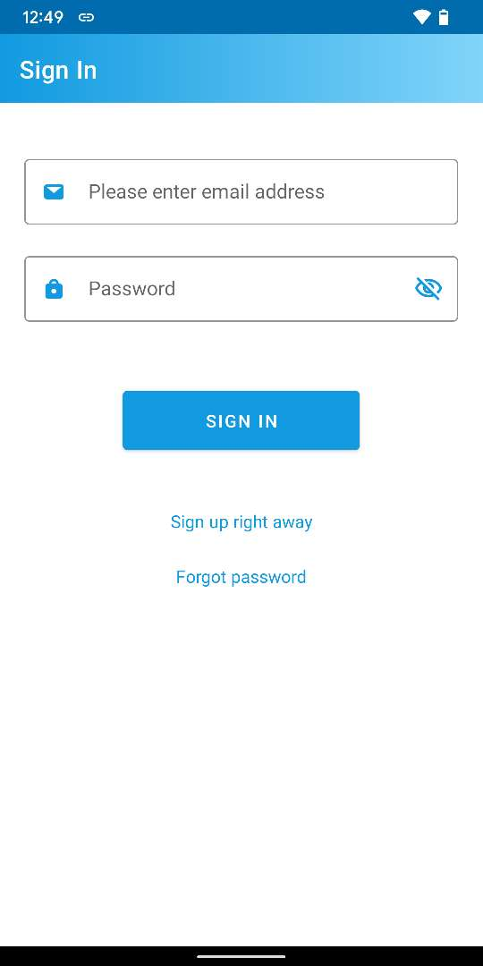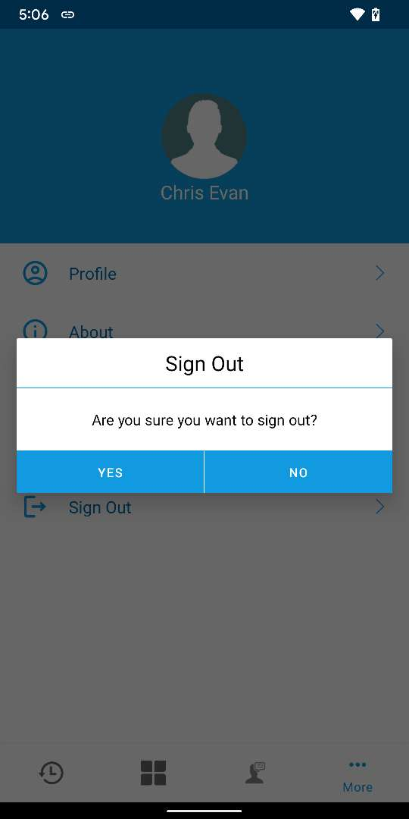

Navigates to “Sign In” page

Press to Sign Out

Press “Yes”

Figure ‑: Sign Out

# Reset Password

## How to request Reset Password from App

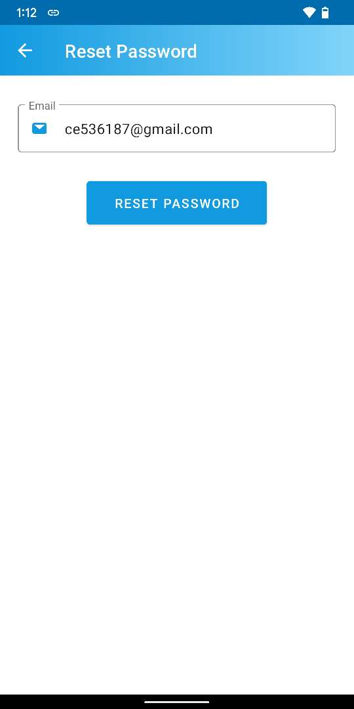

Enter Email and Press “RESET PASSWORD”

Press “Forgot Password” to Reset Password

Loading to request Reset Password

An email to Reset Password is sent to user email address

Press to Sign In after resetting password from email

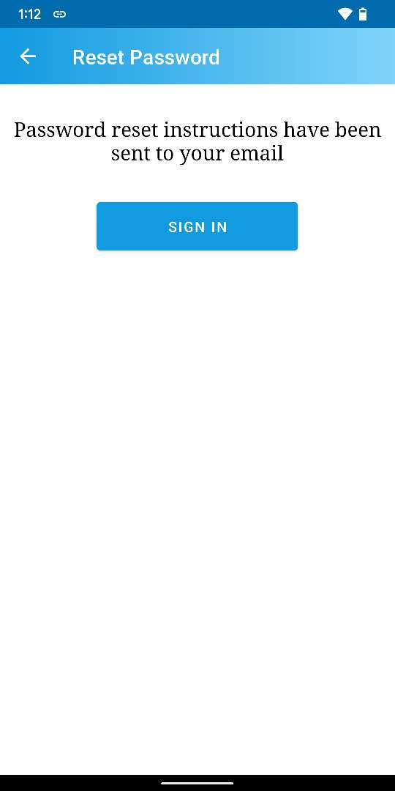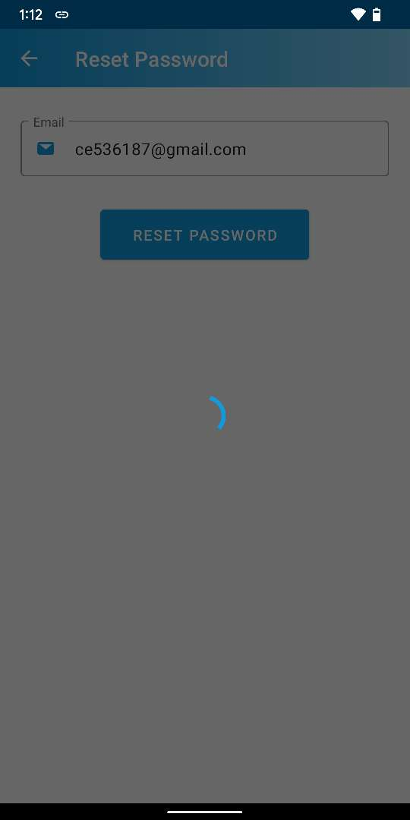

Figure ‑: Request Reset Password from App

Please review How to Reset Password from email section to complete Reset Password from email. Then Sign In with new password and continue using the App.

## How to Reset Password from email

After pressing on “RESET PASSWORD” button from How to request Reset Password from App section, an email will be sent to the email address of the user. From user email, continue reset the Password.

Set “New Password” & “Confirm Password” and Press “Confirm”

Press to Reset Password

Email thread of native email app

Password set successful pop up

Auto signs in into Minu Monitor Web Page

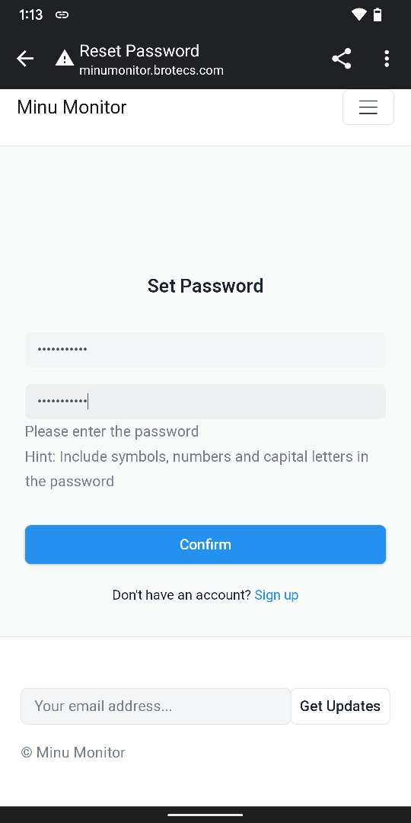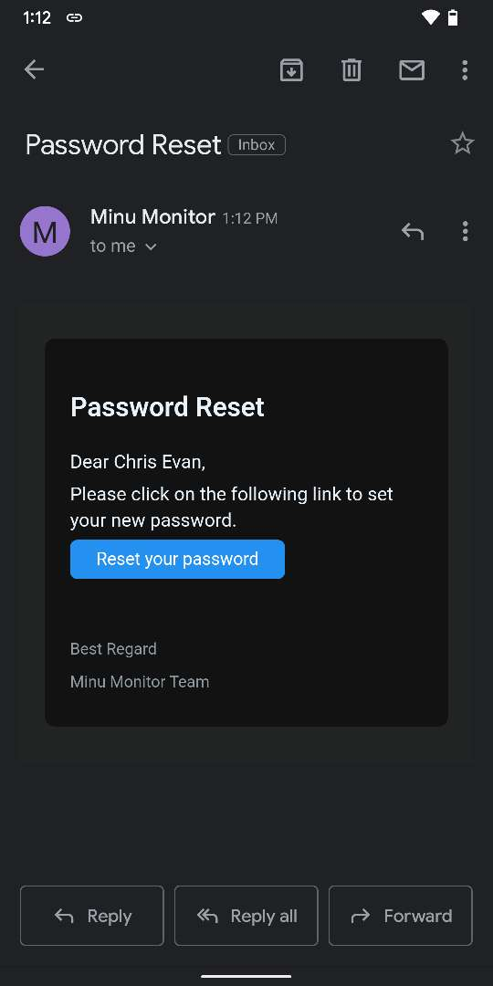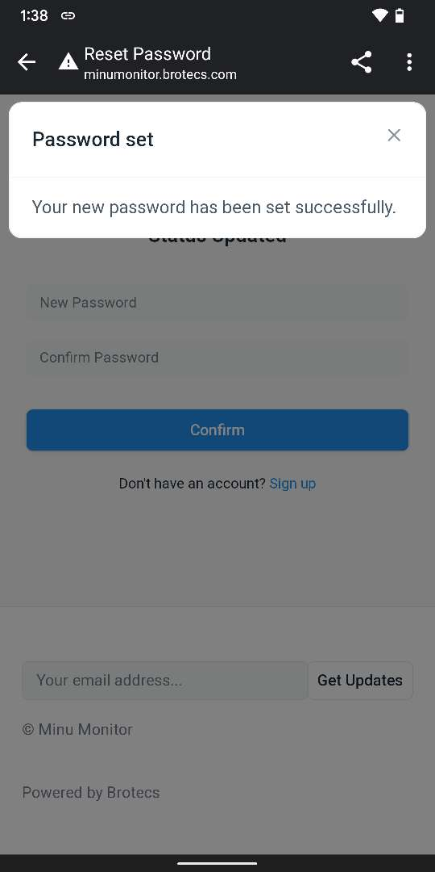

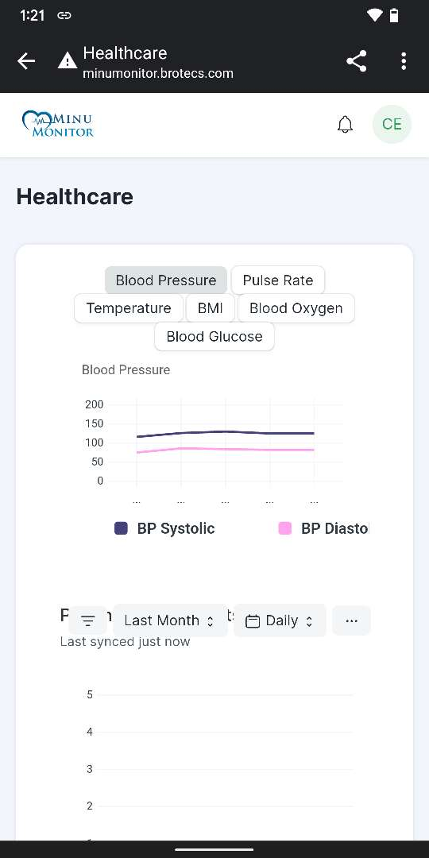

Figure ‑: Reset Password from email

# Appendix A

# How to Login Minu Monitor web as a Patient

Open your preferred browser and enter Minu Monitor – Ground Server’s IP or Domain (i.e., <https://minumonitor.brotecs.com/>), you will be guided to the Minu Monitor Login page.

To Login into the system,

1. Enter a valid registered Email,
2. Enter its valid Password,
3. Click the **Login** button to login.

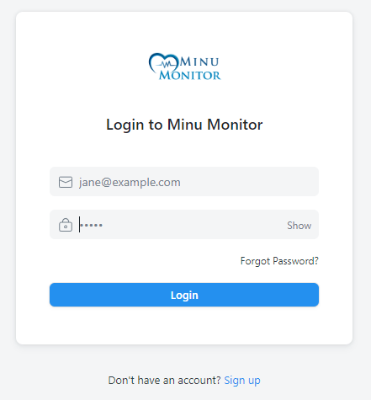

Figure A- :Minu Monitor Web Login Page

## Healthcare Page

The Healthcare is the landing page for the Minu Monitor. Upon successfully Login from the Minu Monitor Login page, the web GUI will be directed to the Minu Monitor ***Healthcare*** *page*.

**Figure A- ii** depicts the view of the Minu Monitor ***Healthcare*** page:

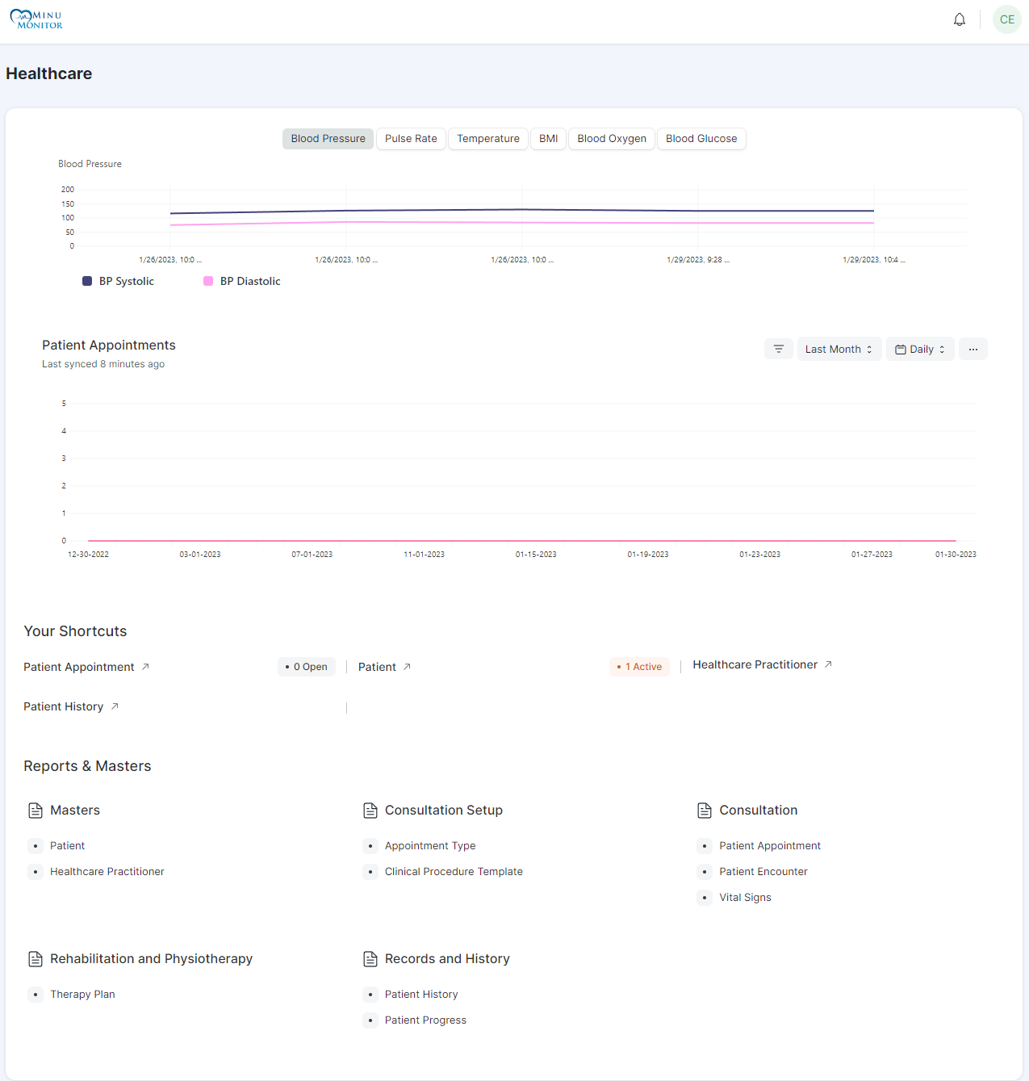

Figure A- : Minu Monitor – Healthcare Page

## Vital records in Healthcare

When the vitals measurements are done from the Android App side, all measurement records can also be seen from the ***Healthcare*** page.

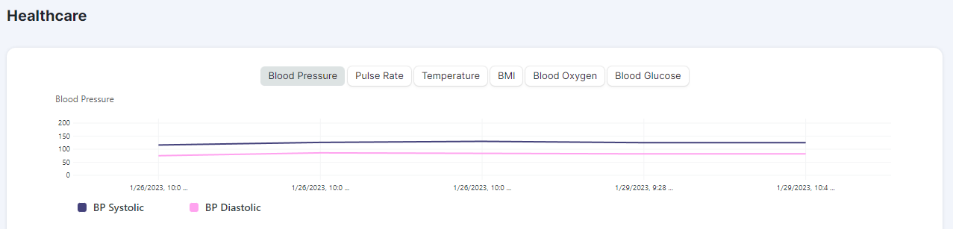The following image depicts the view of all vital records section in ***Healthcare*** page:

Figure A- : Healthcare Page – Vital Records

Please review the Record section to see vital measurement records in App.

## Vital Signs in Healthcare

**Healthcare -> Reports & Masters -> Vital Signs**

After successfully creating appointment from the app, user can view all appointments from **Vital Signs** section of ***Healthcare*** Page.

The following image depicts the view of appointment list in **Vital Signs** section of ***Healthcare*** page:

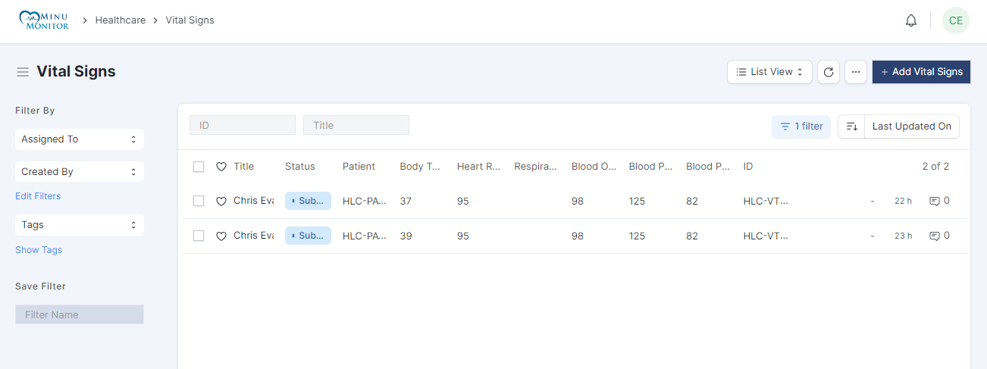Figure A- : Healthcare Page – Vital Signs

Please review the Appointment list section to see appointment list in App.

# Appendix B

Vital Signs Monitor devices vary in their structures according to their manufacturer. We have added all the below images and steps to perform Vital Signs measurement upon considering common structure of a Vital Signs Monitor device.

## Structure of Vital Signs Monitor Device

Figure B- : Structure of Vital Signs Monitor Device

## Guidelines for ECG Measurements

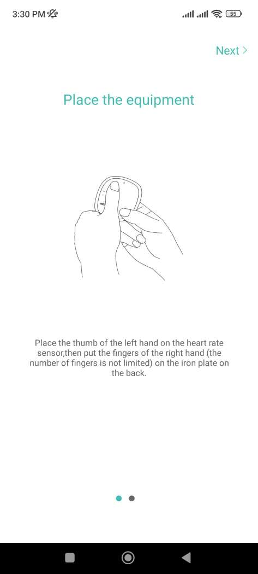

Figure B- : Guidelines for ECG Measurements

Contact the left thumb with the blood oxygen sensor, the two hands should not touch each other. Then place the fingers of the right hand on the metal plate at the back of the device. The power button is palm-facing.

Now continue the measurement procedure from app by following the How to measure ECG section.

## Guidelines for Blood Pressure Measurements

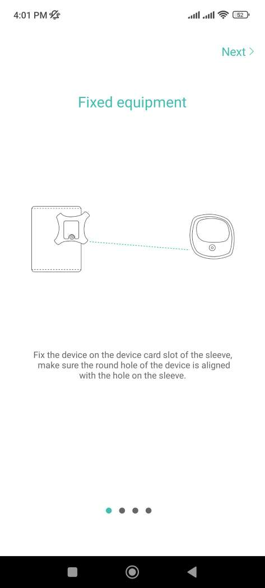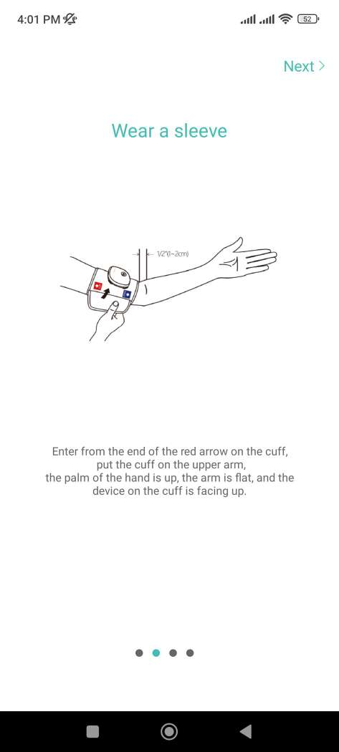

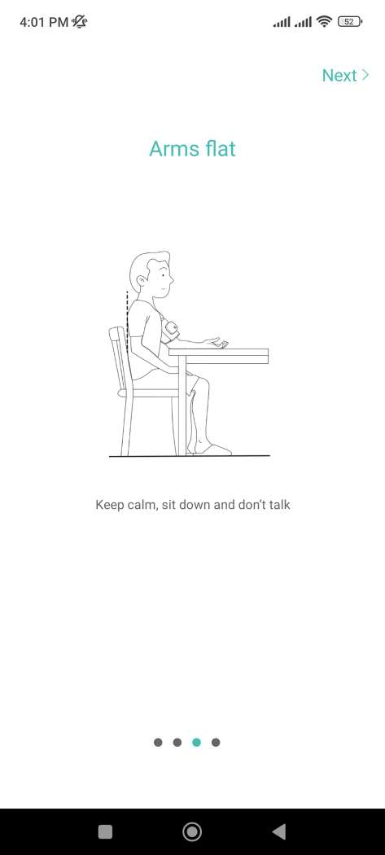

Figure B- : Guidelines for Blood Pressure Measurements

Fix the device on the device card slot of the sleeve and make sure the device is aligned with the hole on the sleeve.

Put the vital signs monitor device to the cuff is approximately 1 to 2 cm above the elbow and loosen or tighten it as long as it’s comfortable.

Keep calm, sit down and don’t talk.

Now continue the measurement procedure from app by following the How to measure Blood Pressure section.

## Guidelines for Blood Oxygen Measurements

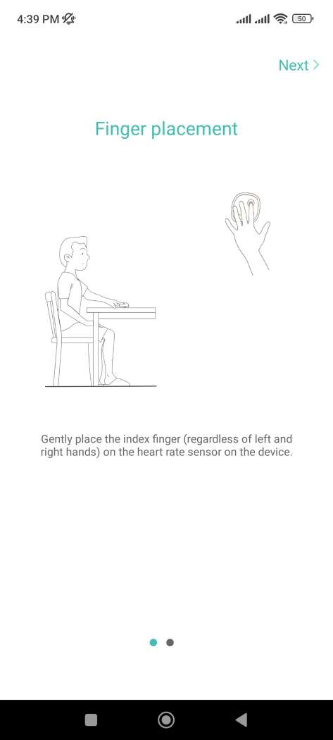

Figure B- : Guidelines for Blood Oxygen Measurements

Adjust your sitting position and keep quiet. Keep the monitor flat on the table. Put the fingertip of the index finger on the oxygen detector.

Now continue the measurement procedure from app by following the How to measure Blood Oxygen section.

## Guidelines for Blood Glucose Measurements

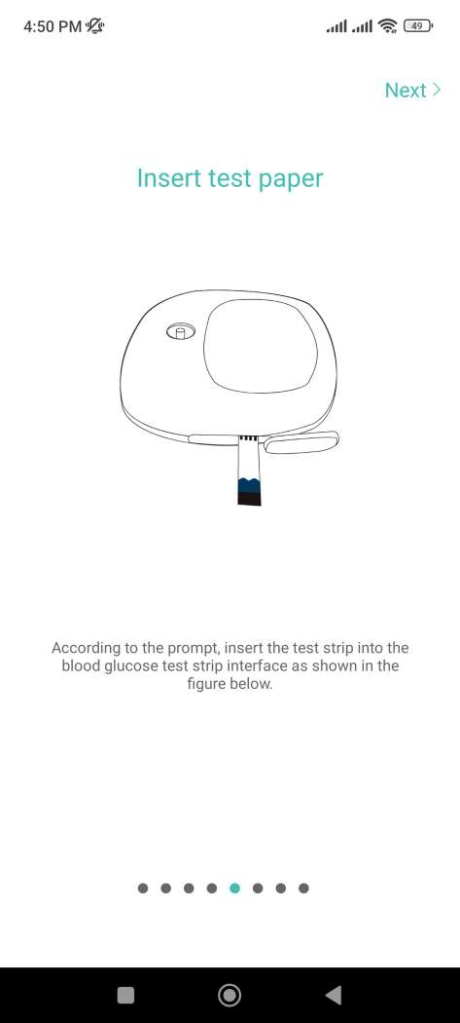

Figure B- : Guidelines for Blood Glucose Measurements

Insert the test script into the blood glucose test strip interface as shown in **Figure B- v**. After the test strip is inserted correctly, drop the blood from your finger on the collection area at the front of the test paper correctly.

Now continue the measurement procedure from app by following the How to measure Blood Glucose section.

## Guidelines for Body Temperature Measurements

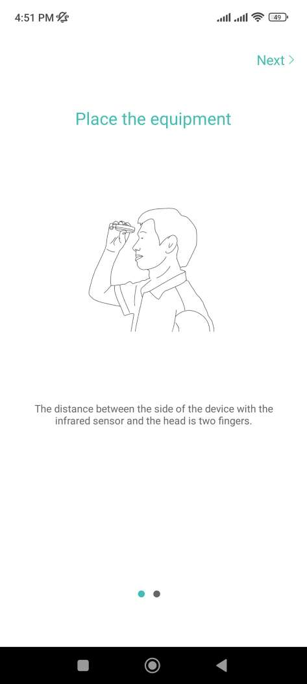

Figure B- : Guidelines for Body Temperature Measurements

Clean your forehead before measuring. The distance between the side of the device with the infrared sensor and the head is two fingers.

Now continue the measurement procedure from app by following the How to measure Body Temperature section.

**==========The End==========**